(Translation)
Notice on the Use of Registered Trademarks

Enacted and promulgated on July 10, 2008
Amended and promulgated on April 20, 2012 by the order of the MOEA, enforced on July 1, 2012

Outline
1. Preface
2. Definition and types of trademark use
2.1. Use on goods
2.2. Use on services
3. Determination of use of registered trademarks
3.1. Subjects
3.1.1. Proprietor of a trademark
3.1.2. Licensees
3.2. Objects
3.2.1. The marks
3.2.2. The goods or services
3.3. Term of trademark rights
3.4. Territory
3.4.1. Export
3.4.2. Use on the Internet
3.5. Evidence
3.5.1. Displaying the trademark
3.5.2. Displaying the date and user
3.5.3. Complying with general practices in the trade
4. Situations which will lead to revocation of trademark registration
4.1. Non-use for three years
4.2. Altered use or use supplemented with additional notes
4.3. Generic terms
4.4. Likely to mislead the public with respect to the nature, quality or place of origin of goods or services
5. Other points to notice
5.1. Non-trademark use
5.1.1. Full name of the company
5.1.2. Ornamental design
5.2. Use of registered trademark with disclaimer
5.3. Application for invalidation or revocation of a trademark registration which shall be accompanied by evidence of use

1. Preface
In Taiwan, trademark registration is on a "first-to-file" basis, and actual use of the trademark is not a prerequisite for an application for registration of the trademark. However, the function of a trademark and the purpose of a trademark registration are not merely about acquiring trademark rights. It is only through actual use of the trademark that consumers may come to associate the trademark with the goods or services, so that the trademark can be used to identify the source, guarantee the quality, and advertise the goods/services, thereby realizing the trademark’s value. The Trademark Act affords the applicant who first files the application the rights to the trademark, whereby an originally non-registered trademark is transformed into a private right of the applicant. If the proprietor of the trademark simply monopolizes the trademark rights and does not actually use the trademark, it goes against the legislative intent of the Trademark Act as this deprives others of the chance to apply to register the trademark and deprives the trademark of its function and value.
Given the importance of exercising trademark rights, the Trademark Act expressly defines in Article 5 the meaning of trademark use, and provides in Article 63 that a proprietor of the trademark shall be obliged to use the trademark after its registration. According to the Act, the registration of a trademark may be revoked under Article 63 if any of the following applies: the trademark has not yet been put to use or such use has been suspended for an uninterrupted period of three years, the trademark is used in part, or the trademark is altered by the proprietor in different forms in which it was registered or supplemented with additional notes. This Notice on the Use of Registered Trademarks is enacted to remind and assist proprietors of trademarks to use registered trademarks correctly and legitimately so as to maintain their trademark rights. This Notice shall apply mutatis mutandis to the use of certification marks, collective trademarks, or collective marks.
2. Definition and types of trademark use
“Use of a trademark” means any of the following act, in the course of trade, where such trademark is capable of being recognized by relevant consumers as a trademark:
(1) to apply a trademark to goods or packaging or containers thereof;
(2) to possess, display, sell, export, or import the goods referred to in the preceding subparagraph;
(3) to apply a trademark to articles relating to the provision of services; or
(4) to apply a trademark to commercial documents or advertisements relating to goods or services.
The preceding circumstances shall also apply to acts performed by digital audio-visual means, through electronic media, on the Internet, or through other media. (Article 5 of the Trademark Act) The term “use of trademark” must at least satisfy the following two requirements: (1) the user must have the subjective intention of using the trademark in the course of trade; and (2) objectively, the use of which must be able to make relevant consumers recognize the trademark as such. The ways to use include applying a trademark to goods or packaging or containers thereof; possessing, displaying, selling, exporting, or importing the goods referred to in the preceding subparagraph; applying a trademark to articles relating to the provision of services; applying a trademark to commercial documents or advertisements relating to goods or services; or applying a trademark by digital audio-visual means, through electronic media, on the Internet, or through other media. The evidence of use of a registered trademark provided by the proprietor shall comply with the general practice of trade. (Paragraph 3 of Article 57 applies mutatis mutandis to Article 67 of the Trademark Act)
2.1. Use on goods
Trademark use on goods mainly refers to placement of the trademark, for promotional purpose, on goods or on packaging or containers thereof or on commercial documents or advertisements relating to goods, such as labels, instructions, tags, price lists, or catalogs, or performed such trademark by digital audio-visual means, through electronic media, on the Internet, or through other media. Therefore, in addition to the typical use of a trademark on goods or their packaging, display of a trademark in advertising media, such as magazines and TV, if the goods of such trademark is capable of being recognized by relevant consumers, is also considered trademark use, because the purpose thereof is to promote the goods that are about to enter or have entered the market. For example, a pharmaceutical company may promote the drugs that it manufactures by using pharmaceutical trademarks on tablets, their packaging boxes, ingredients and instructions, posters, or promotional flyers, by running advertisements on the Internet, TV, radio, newspapers, electronic display boards, or by holding new product introduction conferences.
2.2. Use on services
Trademark use on services means that for the purpose of promoting the services offered to others, the trademark is applied to articles relating to the provision of services, or commercial documents or advertisements relating to services, or performed by digital audio-visual means, through electronic media, on the Internet, or through other media. For example, a restaurant operator may promote the services that it offers by placing the trademark on business signboards, employees’ uniforms, dish plates, menus, price lists, or business cards, by running advertisements on the Internet, TV, radio, newspapers, electronic display boards, or by participating in food shows. Another example: a department store or a warehouse store may promote the retail services that it offers by placing the trademark on articles or documents associated with the retail services, such as business signboards, floor guide boards, signboards indicating the sales areas, clerk uniforms, shop windows, display stands, shopping carts, shopping baskets, shopping bags, cash registers, receipts, or flyers, by running advertisements on the Internet, TV, radio, newspapers, electronic display boards, or by holding anniversary sales or discount events. Nevertheless, use of a trademark that identifies services on goods or their packaging or containers is not trademark use on services if such trademark is used to promote such goods. For example, a warehouse store which provides retail services of general merchandise may also display and sell goods of its own brand to promote such goods; therefore, the use of the trademark on these goods is not trademark use on retail services of general goods.
The use of a trademark on services must be based on actual provision of services or activities to others which differ from the relevant services that are necessary for the sale of the user’s own goods. If the services denoted by a trademark are provided only in connection with the user’s own articles or goods rather than for a large number of non-specific persons, even though there is actual use of that trademark, it will not be considered to be legitimate use. For example, a trademark that is registered for “import/export agency services” means that the user provides services as an import/export agent for others, so use of such trademark on the import/export of one’s own goods cannot be considered legitimate use of the trademark on “import/export agency services.”
3. Determination of use of registered trademarks
The proprietor of a registered trademark has the exclusive right in the trademark in relation to the designated goods or services. (Paragraph 1 of Article 35 of the Trademark Act) That is, the trademark in use must be the trademark as it was originally registered, and it must be used on the goods or services identified in the registration. In determining whether a registered trademark is in use, the factors to be considered include whether the user has, for the purpose of promoting the goods, put the trademark to genuine use in the course of trade, and whether relevant consumers have come to recognize it as a trademark that may distinguish the goods or services from those of others.
3.1. Subjects
3.1.1. Proprietor of a Trademark
In principle, a registered trademark is used by the proprietor of the trademark only. The “proprietor of a trademark” may be a company, a firm, or a natural person. A company and its representative are two different entities. For a trademark “A” owned by the representative, the company’s use thereof and the representative’s use thereof are different. Therefore, use of trademark “A” by the company may not be considered to be use of the trademark “A” by its representative unless the company’s use of the trademark “A” is authorized or consented to by the representative. (The proviso of Subparagraph 2 of Paragraph 1 of Article 63 of the Trademark Act) As for sole proprietorships, if the responsible person of the business is the subject of rights, and whether the right to a trademark is acquired through registration in the name of the business or the responsible person, any evidence of either’s use thereof is admissible as evidence of the proprietor’s use of the registered trademark.
3.1.2. Licensees
A registered trademark may also be used by a person consented to by the proprietor of the trademark, such as a licensee. As the proprietor of the trademark has licensed another to use its trademark, it should be considered to have used the registered trademark legitimately. In other words, after a registered trademark is licensed, the use of it by a licensee can be regarded as use by the proprietor of the trademark; if use of a registered trademark is by neither the proprietor of the trademark nor a party with its consent, it is not considered legitimate use of the registered trademark.
Although a license shall have no locus standi against any third party unless it is entered in the Register by the Registrar Office, whether the trademark is in use is a question of fact. If the proprietor of a registered trademark has licensed others to use its trademark without the entrance of the license in the Register by TIPO, the licensee’s use of the trademark can still be regarded as legitimate use of the trademark by the proprietor of the trademark, so long as there are facts to support the licensee’s use of the trademark.
3.2. Objects
From the perspective of the Trademark Act, the objects of trademark use are trademarks for which registrations are issued and the goods or services identified in the registrations. Therefore, whether a trademark is in use and whether the use thereof constitutes grounds for revocation under Article 63 of the Trademark Act are matters related to registered trademarks and their designated goods or services.
3.2.1. The marks
In principle, a registered trademark should always be used in its entirety as it was originally registered. However, use of a registered trademark in practice in a form which differs from the form in which it was registered, but does not affect the identity of the trademark according to general concepts prevailing in the society, shall be deemed to use the registered trademark. (Article 64 of the Trademark Act) The term “identity” means that the main features used to identify a trademark are not substantially changed even though there are minor differences in form between the trademark actually used and the trademark registered, so the two leave the same impression on general consumers and are perceived to be the same. In such a case, the registered trademark can be considered to be in use. If a main, attention-grabbing portion of a trademark is omitted in use, rendering the trademark so obviously different from the originally registered form that general consumers will not see them as one and the same, such use is not considered use of the registered trademark.
3.2.1.1. Identity
In actual use, change of a registered trademark in terms of size, proportion, font, or arrangement of the words or elements is usually regarded as a minor change of form and does not affect its identity. However, determination of identity or the lack thereof must be made by the facts in each individual case and according to the common ideas in the society and the perception of consumers. The three of the following types of trademark use (numbered (1) to (3)) are considered to have identity and can be regarded as use of the registered trademark:
(1) Changing only the arrangement of the words in the trademark
Text in registered trademark  (Horizontal arrangement of Chinese characters) | Text actually used  (Vertical arrangement of Chinese characters)
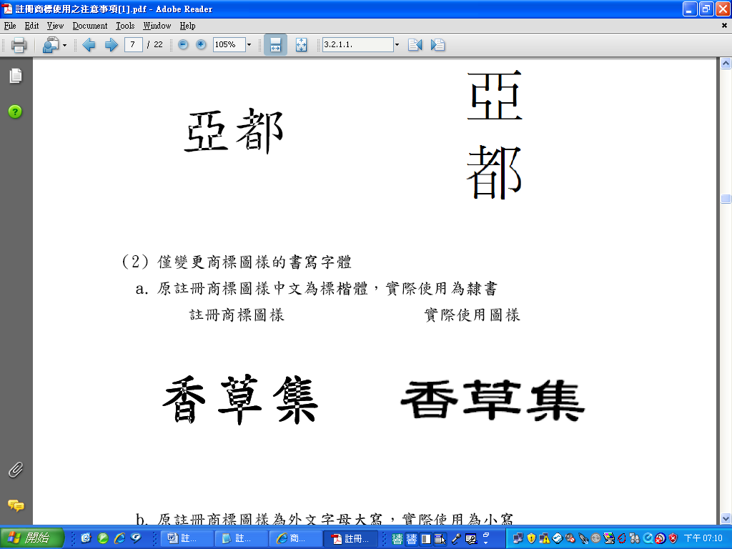
(2) Changing only the font of the words in the trademark
a. The text of the originally registered trademark is in Chinese Biao-Kai font, but the text actually used is in Chinese Li-Shu font.
Text in registered trademark | Text actually used
b. The letters of the originally registered trademark is in capital letters of a foreign language, but the letters actually used is in lower case.
Letters in registered trademark | Letters actually used
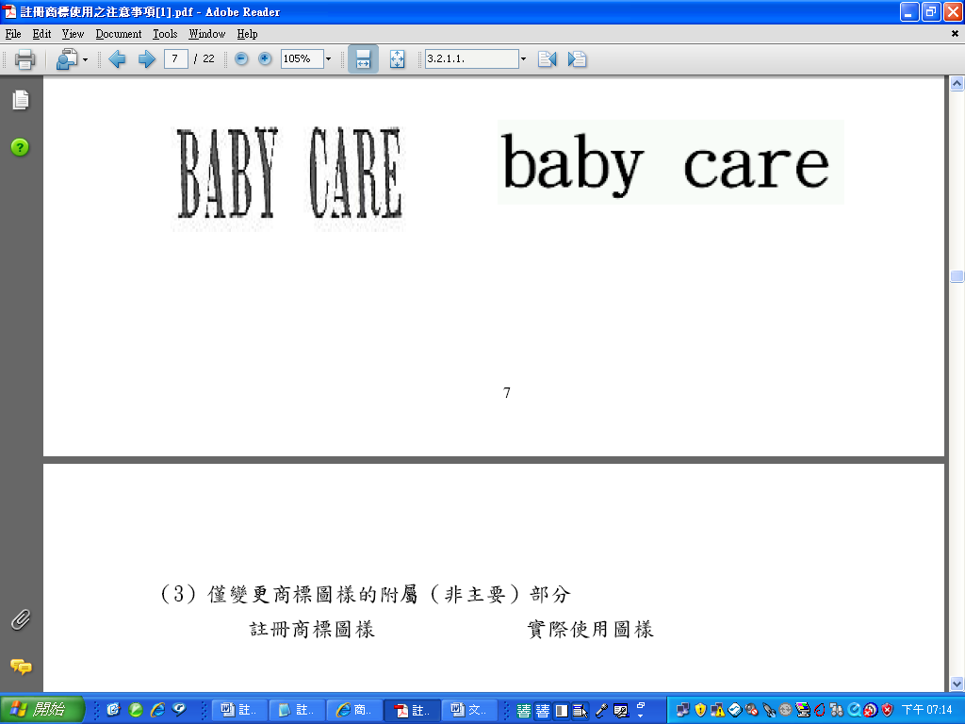
(3) Changing only the subordinate (non-main) portion of the trademark
Design in registered Trademark | Design actually used
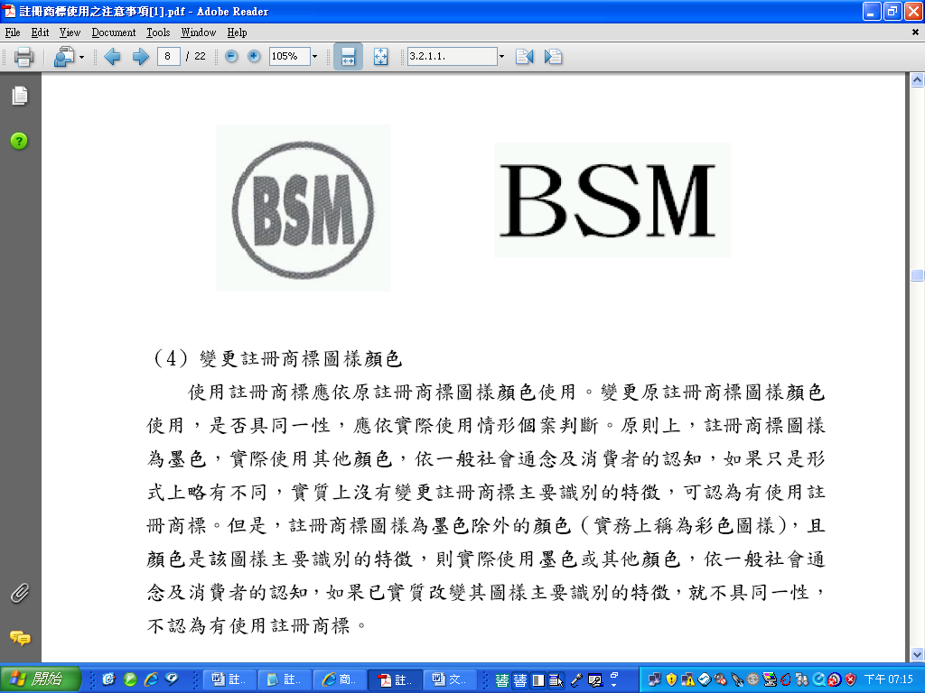
(4) Changing the color of the registered trademark
A registered trademark should be used in the color(s) it was originally registered; whether change of color in the trademark affects identity should be judged by the facts in each case. In principle, when the design of a registered trademark is in black and white but appears in other colors when used, if by common ideas in the society and the perception of consumers, the two are merely slightly different in form and such difference does not substantially change the main features used to identify the registered trademark, then the registered trademark can be considered to be in use. However, in the case of a trademark registered in color(s) other than black and white (which is called “color image” in practice) where the color(s) used are the main identifying feature of the mark, if in actual usage it appears in black and white or a different color, and if such change of color substantially changes the main feature used to identify the registered trademark, the registered trademark will not be considered to be in use since the trademark in use and the one originally registered do not have identity.
a. Trademark registered  (Image in black and white) | Trademark actually sed  (Image in color)(Considered use of the registered trademark)
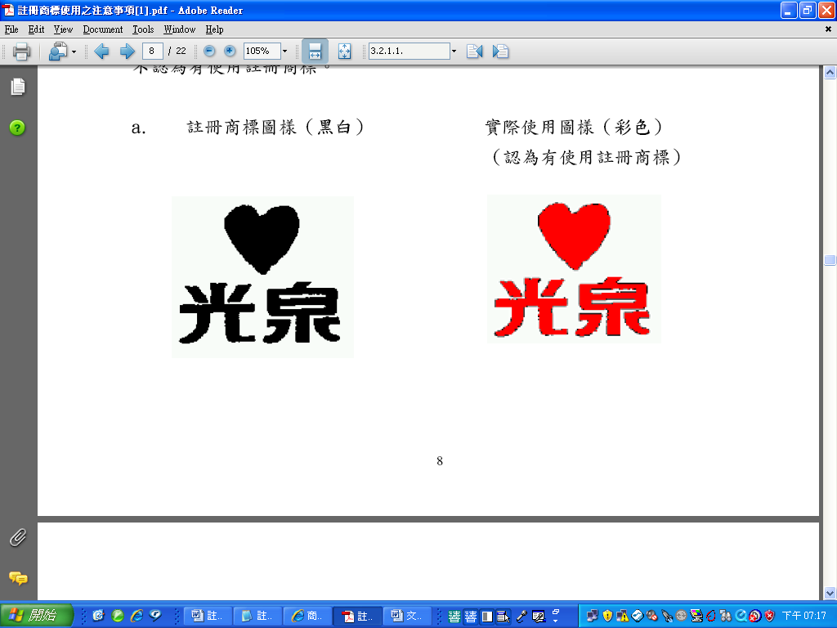
b. Trademark registered  (Image in color) | Trademark actually used  (Image in black and white)(Not considered use of the registered trademark)
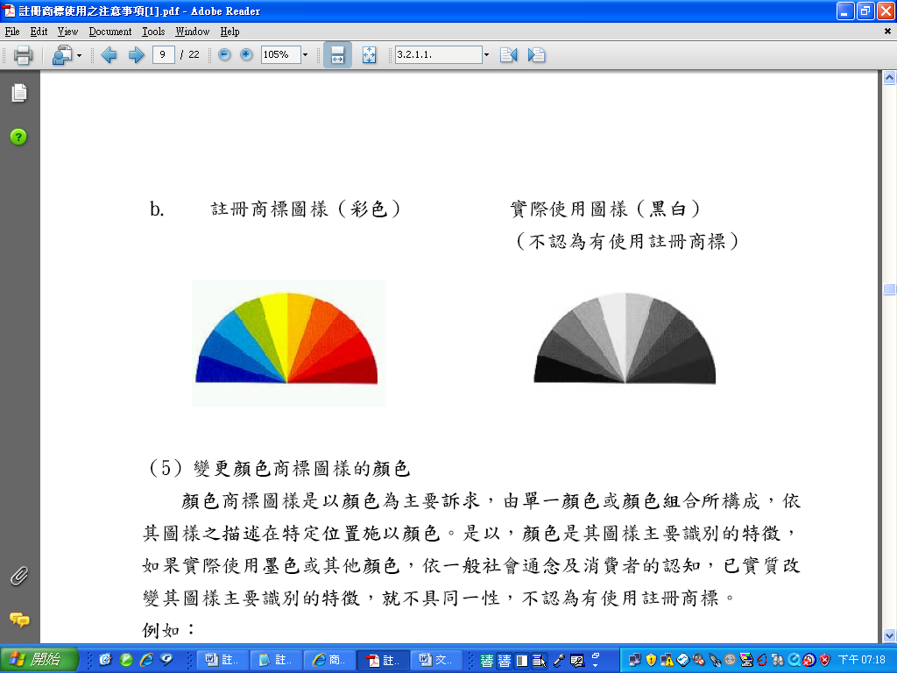
(5) Changing the color of color trademarks
Color is the main feature of a color trademark; it can consist of a single color or multiple colors, and is applied to specific portion(s) stated in the description of the mark. Therefore, color is the main feature used to identify a color trademark. If a color trademark in actual use appears in black and white or other colors, then its main identifying feature is substantially changed, and the identity no longer remains. In such a case, the registered trademark is not considered to be in use.
Trademark registered  (Color trademark) | Trademark actually used  (Image in black and white) (Not considered use of the registered trademark)
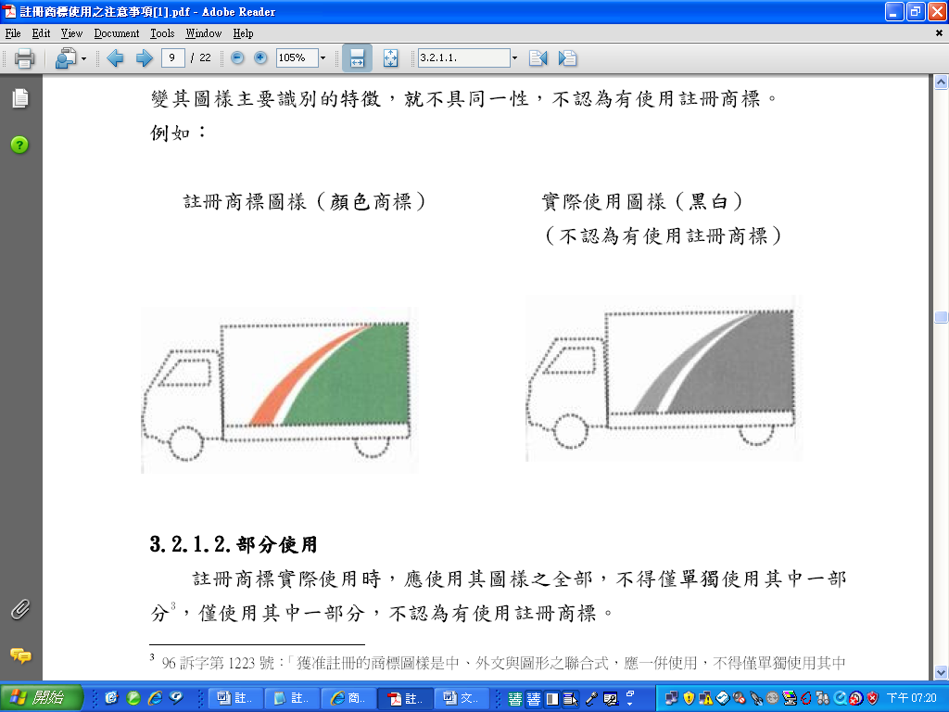
3.2.1.2. Partial use
When actually used, a registered trademark should be used in its entirety; use of any part thereof alone is not allowed. Partial use is not considered use of the registered trademark.
For example:
Trademark registered | Trademark actually used  (Not considered use of the registered trademark)
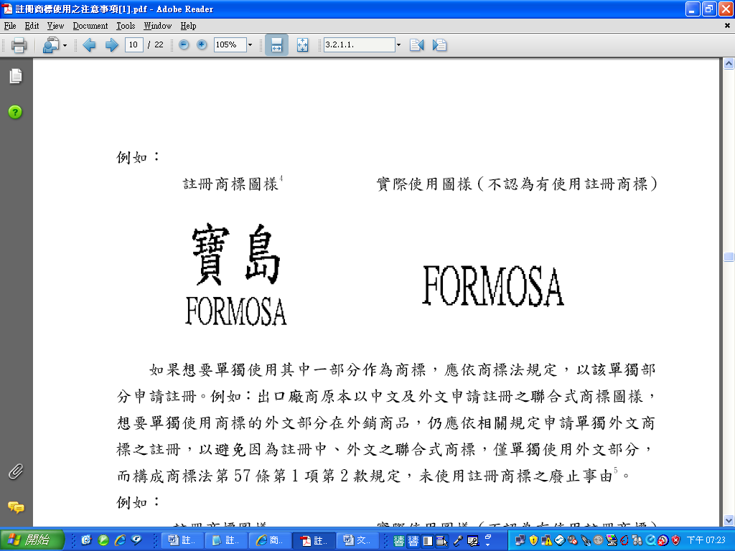
If it is desired that a portion alone be used as a trademark, a separate application should be filed in accordance with the Trademark Act. For example, if an exporter who owns a composite mark comprising Chinese character(s) and foreign word(s) intends to use the foreign word portion alone on the exported goods, an application for registration of the foreign word(s) as a trademark is still required. By doing so, the exporter may prevent the registered trademark from being revoked for non-use under Subparagraph 2 of Paragraph 1 of Article 63 of the Trademark Act when only the foreign word portion of the composite trademark is used.
For example:
Trademark registered | Trademark actually used  (Not considered use of the registered trademark)
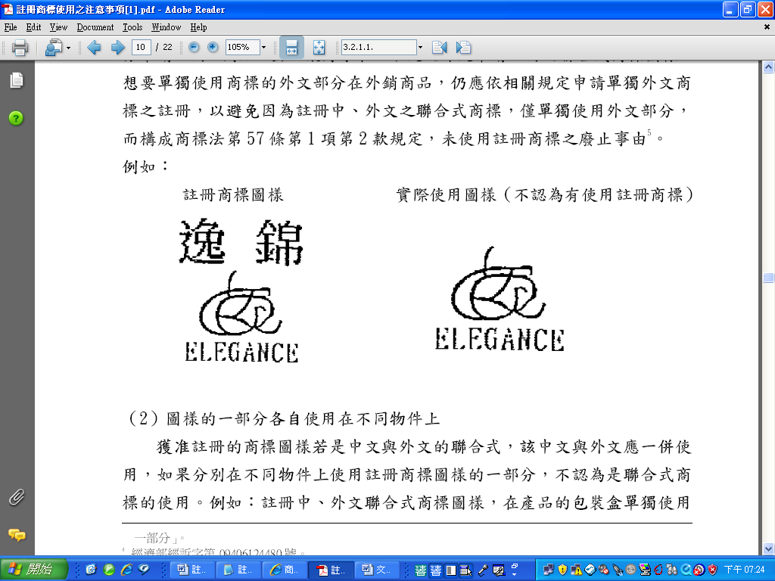

For a registered composite trademark comprising Chinese character(s) and foreign word(s), the Chinese character(s) and foreign word(s) must be used together. Separate use of portions of the registered trademark on different articles does not constitute use of the composite trademark. For example, in using a composite trademark comprising Chinese character(s) and word(s) in a foreign language, if the Chinese portion is used on the packaging boxes of the products and the foreign-language portion is used on the glass container of the products, such use is not considered use of the composite trademark.
3.2.2. The goods or services
When a registered trademark is put to actual use, it should be used on the same goods or services identified in the original registration. Failure to use a registered trademark for three consecutive years without proper reasons may constitute grounds for revocation under Subparagraph 2 of Paragraph 1 of Article 63 of the Trademark Act. According to Paragraph 4 of the same Article, a revocation may be made with respect to only some of the designated goods or services of a registered trademark to which the grounds for revocation relate. Therefore, if a trademark is only in use on some of the designated goods or services, the non-use on the other designated goods or services will constitute grounds for partial revocation of the registration thereof. Therefore, care should be taken to ensure that the range of the goods or services on which a trademark is put to actual use conform to the designated goods or services. For example:
(1) When a trademark registered for use on cosmetics is actually used on compact foundation and the like, the trademark is considered to be in use on cosmetics.
(2) When a trademark registered for use on pharmaceuticals is actually used on pharmaceuticals for animals, the registered trademark is not considered to be in use on pharmaceuticals. This is because pharmaceuticals for animals are drugs approved by the Council of Agriculture for treating or remedying animal diseases, whereas pharmaceuticals are drugs approved by the Department of Health for treating human diseases; they are totally different in purpose and function and are not similar goods. Use of a trademark on one does not equal use thereof on the other.
(3) When a trademark registered for use on banking services is actually used on the services relating to issuance of credit cards, the trademark is considered to be in use on banking services.
(4) When a trademark registered for use on pharmacist dispensary services is actually used on pathological testing services, the trademark is not considered to be in use on pharmacist dispensary services because pharmacist dispensary and pathological testing are totally different services and involve totally different expertise.
In practice, uncertainties are often seen is use of a registered trademark on giveaway items. Whether or not the display of a trademark on a giveaway item equals use of a registered trademark must be judged on the basis of the definition of “trademark use” in Article 5 of the Trademark Act. That is, it depends on whether the trademark is put to genuine use in the course of trade with the user’s subjective intention of promoting the goods or services and whether such use objectively enables relevant consumers to recognize it as the trademark for the goods sold by the user.
If, however, the giveaway items are used merely as a promotional tool, not for the purpose of promoting the giveaway items themselves, and relevant consumers will not regarded the trademark used as the trademark for the giveaway items, such use is not trademark use.
For example:
In holding its anniversary celebration, Department Store α hands out balloons on the street, on which Trademark A appears. The balloons are free gifts and not intended to be sold, but serve as an advertising medium to promote the services provided by Department Store α. Therefore, the display of Trademark A by Department Store α on the balloons is use of the trademark for department store services, not use of the trademark for balloons.
3.3. Term of trademark rights
Once a trademark is approved and registered, the proprietor of the trademark enjoys the rights to the trademark for a term of ten years, and the registration thereof may be renewed every ten years for an unlimited number of times. (Article 33 of the Trademark Act) However, after its registration, a trademark must be put to use in accordance with the law. If, without proper reasons, a trademark has not been used, or use of the trademark has been suspended, for three years, such non-use constitutes grounds for revocation under Subparagraph 2 of Paragraph 1 of Article 63 of the Trademark Act.
The term “proper reasons” means that the proprietor of the trademark fails to use a registered trademark due to a factual obstacle or any other reason not attributable to the proprietor of the trademark and may include the following:
(1) For a pharmaceutical to be offered for sale, a marketing approval from the competent authorities of pharmaceutical affairs must be obtained, and so non-use before such approval is obtained can be considered to be with proper reasons.
(2) Alcoholic products produced in China are not yet allowed to be imported for sale in Taiwan, and so this can be considered to a proper reason for non-use.
（3）When factory production or sale is discontinued due to material damages to the machines caused by interruption of transportation, shortage of raw materials, or natural disasters, these are all proper reasons for non-use.
In the case of a registered trademark under provisional seizure where an injunction is issued against the proprietor of the trademark, the injunction only restricts the proprietor of the trademark from making an assignment or any other disposal of the trademark, not from using the trademark. Therefore, since the proprietor of the trademark should still make continued use of the trademark, in case of an injunction, this is not a proper reason for non-use.
3.4. Territory
Given the territorial nature of trademark registration, the exercise of trademark rights and the resulting preclusion of others’ use of an identical or similar trademark are valid within the territory of Taiwan. Therefore, judgment of whether a trademark is put to use after registration is in principle based on whether the trademark is used on the designated goods or services by the proprietor of the trademark or an authorized user of the trademark within the territory of Taiwan. However, in the following situations, although the products are not sold in Taiwan, the registered trademark may be considered to be in use.
3.4.1. Export
Under Article 5 of the Trademark Act, “in the course of trade” refers to the act of free sale to non-specific persons, and such sale includes sale in the local market and export. “Export” means that products are exported from the territory of Taiwan. Although the commercial transactions following the export are conducted in a foreign market, according to Subparagraph 2 of Paragraph 1 of Article 5 of the Trademark Act, the registered trademark should be considered to be in use so long as it is displayed on the exported goods.
In the case of a foreign proprietor of the trademark where, for example, Party α commissions Party β to manufacture goods under Party α’s trademark A and sells the goods in Party α’s home country or a third country [commonly known in the trade as OEM (Original Equipment Manufacturer) or ODM (Original Design Manufacturer) operations], although the merchandise is not sold directly in Taiwanese market, it is indeed manufactured in Taiwan and such use of the trademark also complies with Taiwanese businesses’ usual practice in international trade, the trademark A can be considered to be in use by Party α.
3.4.2. Use on the Internet
Use on the Internet means that in order to promote their goods or services, the proprietor or a licensee of a trademark, taking advantage of the rapid transmission of information on computer networks, use trademarks on web pages, as a way to attract consumers to browse and purchase their products. As the Internet is a world without boundaries, use of a registered trademark on the Internet should still meet the definition of trademark use in Article 5 of the Trademark Act before it can be accepted as evidence of use. In other words, the user has to have the subjective intention of marketing its goods or services in Taiwan by displaying on web pages the registered trademark and the designated goods or services, and such display is sufficient to be considered to have put the registered trademark to genuine use in the course of trade and to enable relevant consumers to recognize the trademark as such. Take website address as an example. If the top-level domain of the website on which the registered trademark used is “.tw,” in principle, it can be considered that the user aims to market its goods/services in Taiwan and targets consumers within the territory of Taiwan. If the top-level domain relates to another country, then it must be proved that the content of the web pages is for the purpose of marketing the goods/services in Taiwan and is aimed at the consumers within the territory of Taiwan as evidenced by, for example, display of the registered trademark and sales of the designated goods, provision of shipping services to consumers in Taiwan, provision of the option to changing the coding of the web page to Traditional Chinese, etc. In judging whether the use of a registered trademark on the Internet meets the definition of trademark use in Article 5 of the Trademark Act, some other factors may also be considered, including but not limited to the following:
(1) whether consumers indeed browse the relevant web pages or purchased the goods or the services through the information provided on the website;
(2) whether the trademark user provides after-sale guarantees or services, has developed business relationship with individuals within the territory of Taiwan, or is engaged in other commercial activities;
(3) whether the trademark user displays on the web page the address, telephone number, or other contact information necessary for consumers to place an order directly with the user; and
(4) whether the goods or services provided on the website can be legally delivered within the territory of Taiwan, and whether the prices are in New Taiwan dollars.
When use of a registered trademark on website(s) with a foreign domain name only is submitted as evidence of use, attention must be paid to the above factors.
For example:
By submitting receipts, invoices, catalogs of the online shopping site, etc. in connection with orders placed by consumers in Taiwan on the Internet or by facsimile, a proprietor of the trademark proved that local consumers ordered and purchased its goods on the Internet. Therefore, the registered trademark at issue was considered to be in use.
3.5. Evidence
3.5.1. Displaying the trademark
Whether a trademark is in use or not is a question of fact. In a revocation case on the ground of non-use, the proprietor of the trademark is obliged, pursuant to Paragraph 2 of Article 65 of the Trademark Act, to prove use of its registered trademark once a notice of defense is served upon it. Any application filed with the Registrar Office for invalidation or revocation of a trademark registration on the ground that such registered trademark is identical with or similar to a cited trademark and hence there exists a likelihood of confusion shall be accompanied by evidence that, during the period of three years preceding the date of the application for invalidation or revocation, the cited trademark has been used in connection with the goods or services in respect of which it is registered. Therefore, proprietor of the trademarks should always collect and keep evidence of trademark use in the ordinary course of trade or when engaged in other commercial activities. The following are admissible evidence of use of a registered trademark: articles or commercial documents on or in which the trademark is displayed (such as goods, photographs, packaging, containers, order forms for signboards, receipts of decoration costs, contracts, shipping notices, export declarations, advertisements, catalogs, posters, or promotional leaflets, etc.), or business documents or photographs of the business premises related to the service which show the trademark, along with evidentiary documents of revenues from the services offered, such as invoices, receipts, quotations, or relevant advertisements.
The required evidence of use of non-traditional trademarks is basically the same as that of normal trademarks stated above. The evidence of use can be a sample of goods or services, trading documents, catalogs, newspapers or magazines or listing of commercial broadcast on TV or other media, wherein the use is in a manner that consumers can recognize the trademark as such. For example, as a score is merely a description of a sound trademark and does not play the trademark as it is actually used, it cannot serve as evidence of use of the sound trademark by itself.
3.5.2. Displaying the date and user
The evidence of use of a registered trademark should show the registered trademark, the date, and the user, or include information proving the recognizability of the trademark or the date and the user; it can also be a combination of evidence of use that can confirm the objective fact of trademark use. For example, regarding an advertisement placed in a magazine, the front cover or back cover of the magazine usually indicates the date of publication, and the advertisement page will display the trademarked goods being promoted and the name of the manufacturer. If no date is shown on the evidential material, such as catalogs and posters, which usually do not bear any date, additional supporting materials (i.e., proof of the printing date issued by the printing company) must be provided. Or, for another example, there is the name and model number of the goods in the description section of an invoice, but the registered trademark is not displayed. In such a case, a product catalog which includes the model numbers of the goods is admissible as evidence that the proprietor of the trademark uses the trademark to sell the trademarked goods.
For example:
Under general practice in the trade and actual transactions, “brand name” in the column “Name, Brand Name, and Specifications of Commodity” in an import declaration form refers to the trademark that the exporter uses to identify the products that it manufactures and sells. In the case of commissioned manufacture by a foreign company where the products are shipped back to Taiwan and sold under the proprietor of the trademark’s trademark, the proprietor of the trademark will be considered to have used the registered trademark only if relevant documents (such as a contract of commissioned manufacture) are provided to corroborate the fact.
3.5.3. Complying with general practice in the trade
The submitted evidence of use of a registered trademark must not be false or fabricated and must comply with general practice in the trade. (Paragraph 3 of Article 57 applies mutatis mutandis to Paragraph 2 and 3 of Article 67 of the Trademark Act)
For example:
The evidence provided by the proprietor of the trademark is a classified advertisement in a local newspaper as shown below. The advertisement merely indicates how the registered trademarks look and on what goods or services they are used and is not for promoting the goods or services; this is not an indication of the registered trademark being in use.
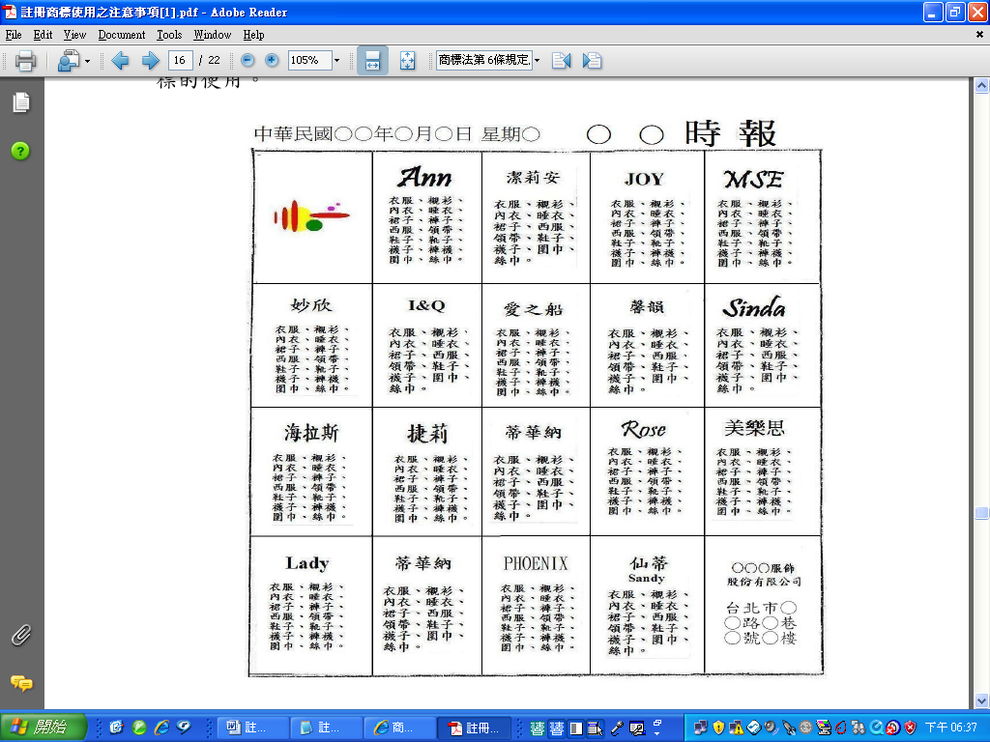
If a registered trademark is licensed, evidence of use by the licensee is acceptable, since trademark use by a licensee can be deemed trademark use by the proprietor of the trademark (The proviso in Subparagraph 2 of Paragraph 1 of Article 63 of the Trademark Act). If there are proper reasons on the non-use or the suspension of use of a registered trademark, such reasons must be explained and relevant evidence must be provided. See Section 3.3 of this Notice for description of proper reasons.
4. Situations which will lead to revocation of trademark registration
To maintain its rights after trademark registration, the proprietor of the trademark must put the mark to continuous, legitimate use. If any of the following occurs, the registration of the trademark may be revoked.
4.1. Non-use for three years
Failure to put a registered trademark to use or failure to use a registered trademark for over three consecutive years after registration without proper reasons constitutes grounds for revocation under Subparagraph 2 of Paragraph 1 of Article 63 of the Trademark Act. However, non-use of a trademark is a passive fact that will be very difficult to prove by a third party. Therefore, in a trademark revocation case, the burden of proof will shift to the proprietor of the trademark as long as reasonable suspicion of such non-use can be established by the petitioner. According to Paragraph 2 of Article 65 of the Trademark Act, a proprietor of the trademark is obliged to prove use of its registered trademark once a notice of revocation is served upon it. For details about “proper reasons,” see Section 3.3 of this Notice; for details about “evidence of use,” see Section 3.5 of this Notice.
4.2. Altered use or use supplemented with additional notes
If the proprietor of the trademark modifies the word(s), device, or color of a registered trademark or adds other words, devices, or colors thereto, and such modification or addition renders the trademark identical or similar to another's registered trademark which is used on the same or similar goods or services, resulting in a likelihood of confusion on relevant consumers’ part as to the source or manufacturer/provider of the goods/services, this constitutes the grounds for revocation under Subparagraph 1 of Paragraph 1 of Article 63 of the Trademark Act.
For example:
（1）The registered trademark at issue was “紅馬REDHORSE and Device,” but it was altered by the proprietor of the trademark so that it consisted of the device of a horse head framed by two circles, where a foreign word “STAINLESS” was placed on the upper part of the band formed by the circles and “RED HORSE” on the lower part of the band. As the alteration rendered the trademark similar to the trademark “ZEBRA & Zebra Head Device,” which was also used on the same or similar goods, it was likely to cause relevant consumers to confuse the two trademarks. Hence, the registration of the trademark at issue was revoked.
The registered trademark | Altered use of the registered trademark | The trademark cited to oppose the registered trademark
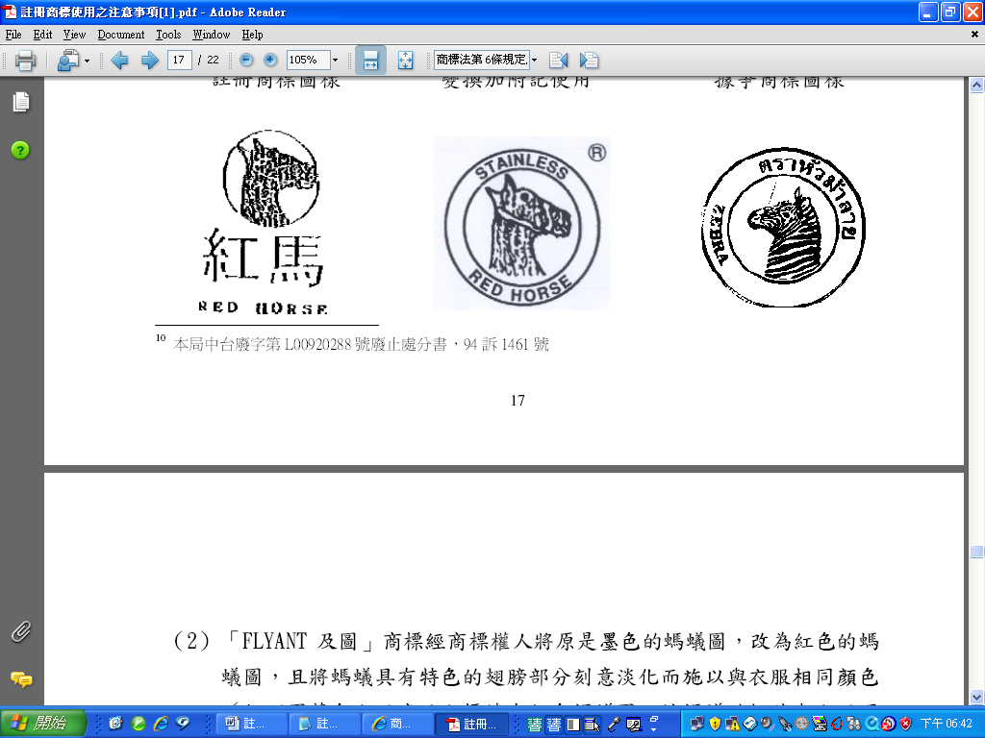

(2) The trademark “FLYANT and Device” was originally in black and white. When used on clothes, it was changed by the proprietor of the trademark and appeared in red, and the wings, which were the distinctive portion of the ant, were intentionally made inconspicuous as they appeared in the same color as the clothes (as illustrated in the figure below, the ant was embroidered in red on the blue shirt, while the wings were blue, like the shirt). Further, in the originally registered device, the ant was walking rightward; the proprietor of the trademark altered it by having the ant walk leftward. A comparison of this altered version and the cited trademark “per GIB and Device” revealed that both had the same color and an ant walking left. Inasmuch as they were both used on coats and the like, there was a likelihood of confusion on the part of relevant consumers. Hence, the registration of the trademark was revoked.
The registered trademark | Altered use of the registered trademark | The trademark cited to oppose the registered trademark
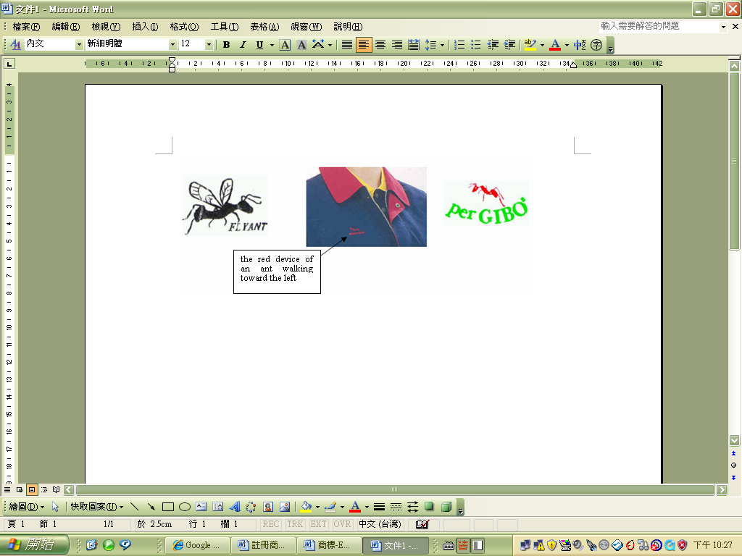
4.3. Generic terms
A trademark will lose its function of identifying a particular source if, after registration, it is used improperly by the proprietor of the trademark or the proprietor of the trademark allows third parties to use the trademark as a name for the goods so the trademark becomes a generic term for the goods on which it is used. This constitutes the grounds for revocation under Subparagraph 4 of Paragraph 1 of Article 63 of the Trademark Act. For this reason, use of a registered trademark as a name, byword, or synonym for the product should be avoided. Generally, a registered trademark becomes generic because the product bearing the trademark is so novel and popular that consumers simply use the trademark to refer to the product when they make the purchase. In other instances, businesses use the registered trademark to refer to similar products that they launch and, over time, the trademark becomes the byword for the product and is commonly used by consumers or businesses. Such use will cause a trademark to lose its function as a source indicator, and consumers can no longer use it to identify the source of the product.
One of the ways to prevent a registered trademark from becoming a generic term for the designated goods is to use the trademark together with the product name, thus making the trademark serve as an adjective to indicate (describe) the source of the product. For example, 大同電鍋 (Tatung electric wok) and 黑松沙士 (Hey Song sarsaparilla drink). Moreover, when a new product is successfully developed, and especially when it is the first of its kind in the industry, the company should clearly inform consumers of the product name when launching the product, so as to prevent consumers from simply using the trademark to refer to the new product when they do not know what to call it. For example, when “NESCAFE” instant coffee was launched, both the trademark “NESCAFE” and the product name “instant coffee” were displayed on the product, so that consumers would not call the product “NESCAFE.” Meanwhile, whether a trademark has become a generic term for a product is judged mainly by whether the impression left by the trademark and its primary meaning in the minds of consumers is the name of the manufacturer or that of the product. Therefore, wherever possible, a registered trademark should be used in a way which is distinctive enough to grab the consumers’ attention and make them recognize it as a trademark. Moreover, a trademark may, if registered, be displayed with the words “registered trademark” or the internationally used symbol for registration (the letter R enclosed within a circle), which can be a way to reinforce consumers’ impression of the trademark, to inform them that the trademark is a registered one, and to remind the third parties from infringement, so as to maintain trademark rights. (Paragraph 3 of Article 35 of the Trademark Act) In addition, for the proprietor of the trademark, taking the initiative to stop others from using its registered trademark improperly is also an important means of protecting its own trademark rights.
For example:
The trademark “猫眼” was registered for use on reflector mirrors and rear lights for cars, motorcycles, and bicycles. Later, in a revocation case, the petitioner cited the “技術尖兵” magazine and the search results from Google to show that “貓眼” (cat’s eye) had become a name commonly used by manufacturers of road reflectors and had therefore lost its function as a trademark. Accordingly, the registration of the trademark on “various reflectors for use as road markers, reflector lamps” was revoked under Subparagraph 4 of Paragraph 1 of Article 63 of the Trademark Act.
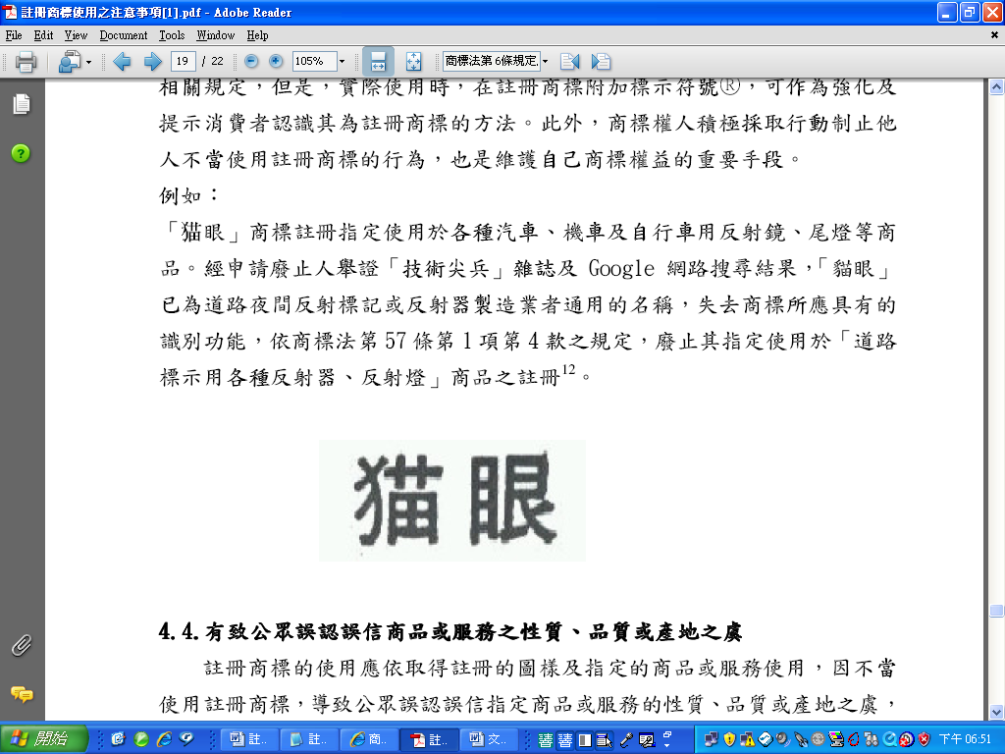
4.4. Likely to mislead the public with respect to the nature, quality or place of origin of goods or services
A registered trademark should be used as it was registered and on the designated goods or services. Any improper use of a registered trademark which is likely to mislead the public with respect to the nature, quality or place of origin of designated goods or services constitutes the grounds for revocation under Subparagraph 5 of Paragraph 1 of Article 63 of the Trademark Act.
For example:
The trademark “慈愛有機商行 and Device” was registered for use on “retail sale of agricultural products, food and beverages, and organic food.” However, some agricultural chemical residues were detected in the oranges produced by the proprietor of the trademark. In TIPO’s opinion, the use of the trademark contradicted the term “有機” (“organic”) in the trademark and was likely to mislead the public into believing that its goods or services were free of agricultural chemicals. As the public was likely to purchase the goods or services on the basis of the mistaken belief, such use of the trademark would disturb normal trade order. Hence, the registration was revoked.
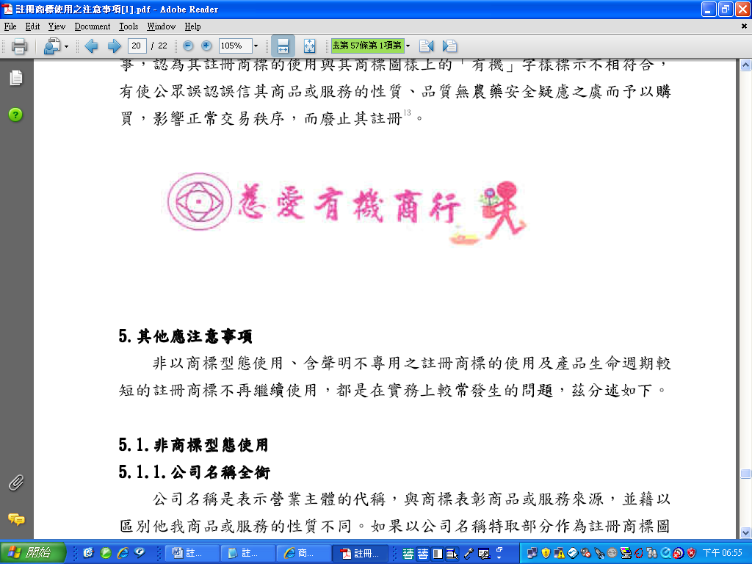
5. Other points to notice
The following will discuss issues that frequently arise in practice, including non-trademark use, use of a registered trademark with a disclaimer.
5.1. Non-trademark use
5.1.1. Full name of the company
The name of a company is a designation used to refer to a business entity. It differs from the trademark, which is used to identify the source of the goods or services and to distinguish them from those of others. In the case where the trademark sought to be registered is the core part of a company name, if it is the full name of the company that appears in actual use on the goods or their packaging or other relevant business articles or documents, it should be considered use of the company name, rather than use of the registered trademark.
5.1.2. Ornamental design
An ornamental design decorates the goods, and so in principle it is not functioning as a trademark. On the basis of the common ideas in the society and the perception of relevant consumers, if a registered trademark is used as an ornamental design, it can hardly be recognized as a trademark, and so it is not trademark use. Whether the use of an ornamental design is trademark use or purely for decorative purpose has to do with how and where businesses in the relevant field in display trademarks. For example, businesses in the clothing industry usually display trademarks on neck labels, pockets, sleeves, or front of the clothes, and businesses in the sports shoes industry usually display trademarks on the sides of shoe uppers. Evidence that the registered trademark is displayed in a manner in compliance with the practice in the field is more likely to establish trademark use.
The perception of relevant consumers is also one of the important factors in judging whether an ornamental design may serve as evidence of use of a registered trademark. For example, the repeating pattern of an ornamental design on the surface of a leather bag was non-distinctive and therefore unregistrable as a trademark. However, through long and extensive use by the bag manufacturer, the ornamental design had become recognizable to relevant consumers as a trademark and acquired distinctiveness, so registration was granted. Later, a leather bag was submitted as evidence in support of trademark use after registration. Although the registered trademark was used as a repeating pattern on the surface of the entire leather bag, such evidence was admissible because relevant consumers had come to recognize such repeating pattern as a trademark.
5.2. Use of registered trademark with disclaimer
Where the registered trademark is derived from words, the proprietor of the trademark has the exclusive right of stylized words or incorrect words in the trademark. However, where the original words or correct words in a non-stylized font are not distinctive, the applicant shall state that he/she disclaims any exclusive right to such words only if such words could give rise to doubts as to the scope of the trademark rights. Nevertheless, the registered trademark will not be considered to be in use unless it is used as it was designed.
For example:
(1)
Trademark registered | Trademark actually used  (Not considered use of the registered trademark)
 | 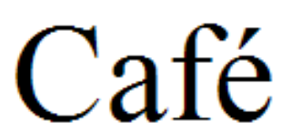

The trademark is registered for use on “coffee, beverages made from coffee, beverages made from cocoa”. “CAFÉ” is a descriptive term commonly used in related business and there is no need for disclaimer.
(2)
Trademark registered | Trademark actually used  (Not considered use of the registered trademark)
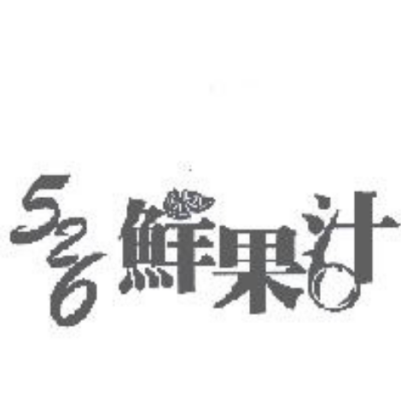 | 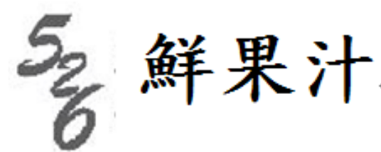

The trademark is registered for use on “tea shops, cafeterias, snack bars, ice cream shops”. “鮮果汁” is a generic term of the goods and there is no need for disclaimer.
5.3. Application for invalidation or revocation of a trademark registration which shall be accompanied by evidence of use
A trademark is a sign which can be used to identify the source of trade. It must be put into the market in practice in order to be functional as a trademark, accumulate the good will and create the value of a trademark. Therefore, whether there exists a likelihood of confusion on the market in respect of two trademarks shall be determined on the basis of actual use of two trademarks on the market in order to meet the necessity of trademark protection. Hence, where a proprietor of an earlier trademark claims that a trademark registered by another person is identical with or similar to his/her earlier registered trademark and to be applied for goods or services identical with or similar to those for which the registered trademark is protected, and hence there exists a likelihood of confusion on relevant consumers (Subparagraph 10 of Paragraph 1 of Article 63 of the Trademark Act), if the earlier trademark has been registered for three years or more, such application for invalidation shall be accompanied by evidence that, during the period of three years preceding the date of the application for invalidation, the earlier trademark has been used in connection with the goods or services in respect of which it is registered, or that there are proper reasons for non-use. (Paragraph 2 of Article 57 of the Trademark Act) The evidence of use provided shall be capable of establishing the genuine use of the trademark and comply with the general practice of trade. (Paragraph 3 of Article 57 of the Trademark Act) In addition, in order to prevent a proprietor of an earlier trademark which has never been used on the market from claiming that a trademark registered by another person is identical with or similar to his/her earlier registered trademark, and hence there exists a likelihood of confusion on relevant consumers, (Subparagraph 1 of Paragraph 1 of Article 63 of the Trademark Act) if the earlier trademark has been registered for three years or more, such application for revocation shall be accompanied by evidence of use, or that there are proper reasons for non-use. (Paragraph 2 and 3 of Article 57 apply mutatis mutandis to Paragraph 2 of Article 67 of the Trademark Act) See Section 3.3 of this Notice for description of proper reasons and Section 3.5 for description of evidence of use.
The proprietor of a registered trademark only needs to provide evidence of use of the registered trademark in respect of goods or services which he/she claims that there exists a likelihood of confusion, rather than evidence of use of the registered trademark in respect of all of the goods or services designated in the registration where the proprietor shall provide in a revocation case on the ground of non-use. (Subparagraph 2 of Paragraph 1 of Article 63 of the Trademark Act)

Decision of the Supreme Administrative Court, Case No. 88-Pan-3467.
Case No. 95-Su-3716, in which it was stated: “In principle, a registered trademark should be used in its entirety as it was originally registered. If the size, proportion, or font of the trademark is changed in actual use, then such trademark can only be considered as being in use when the changed version can still be recognized as the same as the registered version by common ideas in the society. If a main, attention-grabbing portion of a trademark is omitted in use, rendering the trademark so obviously different from its originally registered form that the two will not be regarded as one and the same, such use is certainly not considered use of the registered trademark.”
Court Case No. 95-Su-3716: “The trademark as registered consists of a combination of Chinese and foreign words and a device. Therefore, all the elements must be used together; use of any individual part alone is impermissible.”
Decision of the Ministry of Economic Affairs, Case No. Ching-Su-09406124480.
Court Case No. 95-Su-03716: “The trademark at issue consists of a combination of Chinese characters, a word in a foreign language and a device. Although the plaintiff submitted invoices and a photograph of the sample eyeglasses, some of the invoices did not show the trademark used on the goods, and in the photograph only the foreign word portion and the device were displayed…. On the eyeglasses shown in the photograph, only the device and the foreign word “ELEGANCE” were used; the Chinese characters “逸錦,” which are the most conspicuous portion of the trademark at issue, are not shown. Hence, the trademark at issue cannot be considered to be in use.” (Revocation Decision of this Office, Case No. L00940027)
Judgment of the Administrative Court, Case No. 55-Pan-301.
Decision of the Ministry of Economic Affairs, Case No. Ching-Su-09506180090, in which it was indicated: In the case of a registered trademark under provisional seizure where an injunction is issued against the trademark right holder, the injunction only restricts the trademark right holder from making an assignment or any other disposal of the trademark, not from using the trademark. Therefore, an injunction is not a proper reason for non-use.
Court Case No. 95-Su-03419 (Revocation Decision of this Office, Case No. 940007)
Decision of the Ministry of Economic Affairs, Case No. Ching-Su-09606069850.
Revocation Decision of this Office, Case No. L00920288, and Court Case No. 94-Su-1461.
Revocation Decision of this Office, Case No. L00920008.
Revocation Decision of this Office, Case No. L00940340.
Revocation Decision of TIPO, Case No. L00940033.
Registration No. 01304614.
Registration No. 01309072.

