(Translation)
Examination Guidelines on Disclaimers
Formulated and promulgated as per the MOEA's Order No. Jing-Shou-Zhi-Zi-09820031440 of 16 November 2009
Amended and promulgated as per the MOEA's Order No. Jing-Shou-Zhi-Zi-10120030691 of 2 May 2012
Effective as of 1 July 2012

Table of Contents
1. Preface 4
2. Meaning of disclaimer and application of the provisions 4
2.1 Meaning of disclaimer 4
2.2 Application of the provisions on disclaimer 6
2.2.1 Provisions governing disclaimer 6
2.2.2 Effect of disclaimer 8
3. Determination of whether the applicant shall state that he/she disclaims any exclusive right to an element 9
3.1 Non-distinctive words 9
3.1.1 Descriptive words 10
(1) Situations in which a disclaimer is not required 10
(2) Situations in which a disclaimer is required 13
3.1.2 Generic terms 16
3.1.3 Other non-distinctive words 17
(1) Circumstances where no disclaimer is required 17
(2) Elements to be disclaimed for exclusive right to use 20
3.1.4 For stylized words, a disclaimer of the non-stylized original form should be made if such original form is likely to give rise to doubts as to the scope of trademark rights. 25
3.1.5 When an incorrect word is deliberately used and its correct form is likely to give rise to doubts in respect of the scope of trademark rights, the correct form should be disclaimed. 27
3.1.6. Disclaimer involving foreign words 28
3.2 Non-distinctive designs 30
3.2.1 Descriptive designs 31
3.2.2 Generic marks 34
3.2.3 Other non-distinctive designs 35
(1) Religious signs and folk belief signs 35
(2) Decorative patterns, appearance and packaging design of goods 36
3.3 Non-distinctive elements such as numbers, signs and model numbers 37
4. Other situations in which a disclaimer is not required 40
4.1 Special combination of non-distinctive words 40
4.2 Use of homophones that creates a novel and unique impression 41
4.3 Acquisition of distinctiveness through use 42
5. Situation in which disclaimers are not applicable 43
5.1 Trademarks having no distinctiveness in their entirety 44
5.2 Elements which are likely to mislead the public in respect of the nature, quality or place or origin of goods or services 45
5.3 Purely informative elements 47
6. Forms of disclaimer 49
6.1 Disclaimer involving several elements 49
6.2 Disclaimer in respect of specific classes or some of goods/services only 50
6.3 Disclaimer in respect of a trademark that is mainly not distinctive 51
6.4 Disclaimer involving obsolete Chinese and Simplified Chinese 52
6.5 Disclaimer involving foreign words 53
7. Other matters 55
7.1 When no response is made by the time limit after receipt of a notice of disclaimer 55
7.2 When non-disclaimed words in a registered trademark become non-distinctive in a later-filed application 56
7.3 Acquisition of distinctiveness after a disclaimer is made 57
7.4 Distinctive elements may not be disclaimed for exclusive right to use 58
7.5 No publication will be made for the element of a trademark that is disclaimed by the applicant but is unlikely to give rise to any doubts over the scope of trademark rights 58
7.6 Determination of likelihood of confusion should be based on overall observation 59

1. Preface

The Republic of China (Taiwan) adopted the disclaimer system in 1991, and formulated the Main Points for Examination of Disclaimers ("Main Points") in 2000. The Main Points, which was published and came into force on 28 December 2000, addresses the meaning and applicable scope of the disclaimer system, and gives examples to illustrate the application thereof. In light of the amendment to the Trademark Act, minor changes were made to the Main Points in 2004. As the Main Points has been in force for several years and is in the form of a list, it is not a detailed document, and trademark examiners often find it inadequate in practice. Therefore, the Examination Guidelines on Disclaimers was initially formulated on 1 January 2010 to serve as a reference for trademark examination. To comply with the amendment to the Trademark Act in 2011, the disclaimer system, which originally prescribes that where the reproduction of a trademark contains an element which is not distinctive, the applicant shall state that he/she disclaims any exclusive right to such element, is amended to that the applicant shall state that he/she disclaims any exclusive right to such element only where the inclusion of that element in the trademark could give rise to doubts as to the scope of the trademark rights. The Guidelines is then revised accordingly.

All examples cited in the Guidelines are actual trademark applications. However, in order to comply with the formulation of the Guidelines, some of the examples may not be identical to the registered information, such as the designated goods or services, the element to which any exclusive right is disclaimed, or the form of the disclaimer.

2. Meaning of disclaimer and application of the provisions

2.1 Meaning of disclaimer
A trademark shall refer to any sign with distinctiveness, which may, in particular, consist of words, designs, symbols, colors, three-dimensional shapes, motions, holograms, sounds, or any combination thereof. The term “distinctiveness” refers to the character of a sign capable of being recognized by relevant consumers as an indication of the source of goods or services and distinguishing goods or services of one undertaking from those of other undertakings (Paragraphs 1 and 2, Article 18 of the Trademark Act). Therefore, the function of a trademark is mainly to indicate the source of goods or services and to distinguish goods or services of one undertaking from those of other undertakings. Where a trademark as a whole is distinctive, it functions as a trademark. For promotional purposes, an applicant is often inclined to include descriptions relating to the quality, function or place of origin of the goods or services or non-distinctive elements such as advertising slogans in the trademark to be applied for registration. Even if the entire trademark is distinctive enough to be registrable, opinions differ on whether the trademark owner or any competitor has the exclusive right to use the foregoing elements included in the trademark. If a trademark owner claims his/her rights to the non-distinctive element of a trademark against competitors, even if such claim would eventually be not accepted by the court, the competitors may face the off-shelving of the goods in dispute by distributors during the proceedings and must also spend time, efforts and expenses to deal with such dispute and relevant litigation. This would likely affect fair competition and order in the market.

Before the Trademark Act was amended, where the reproduction of a trademark contains an element which is not distinctive, the applicant shall state that he/she disclaims any exclusive right to such element. However, along with the operation of the disclaimer system, suggestions on changes to this practice emerge. As noted, a non-distinctive element may be the description or generic mark or term of the designated goods or services that are commonly adopted by such industry; for example, "新鮮美味" ("fresh, delicious") for toast and bread and "土地銀行" ("Land Bank") for banking services. As "新鮮美味" is the description of the designated goods and services and "銀行" is a generic term of the designated goods and services, they are clearly and precisely non-distinctive, and could not give rise to doubts as to the scope of the trademark rights. If the applicants are still requested to provide a statement of disclaimer during examination, it would be just time-consuming and affect the efficiency of examination.

The purpose of the disclaimer system is to avoid the situation whereby a trademark owner may, after obtaining the registration of a trademark, uses the acquired scope of trademark rights to claim his/her rights, based on subjective recognition and non-distinctive element of the trademark, thus causing inconvenience to competitors within the same trade, or to blur the protected scope of trademark rights by not using the disclaimer system, causing hesitation among competitors who may wish to use the non-distinctive elements, and such would be against the concept of fair competition within the market. Considering examination efficiency and fair competition in the market, the Amendment to the Trademark Act prescribes that the disclaimer system is used where a trademark, after examination, is found to have a non-distinctive element of which the inclusion in the trademark “could give rise to doubts as to the scope of the trademark rights”. In other words, an applicant should state that he/she disclaims any exclusive right to such “non-distinctive element” of a trademark that is not registrable alone under the law; with a disclaimer, a trademark that is distinctive as a whole may keep the element that is not registrable alone, and the scope of the trademark rights is more specific.

2.2 Application of the provisions on disclaimer

2.2.1 Provisions governing disclaimer
Where the reproduction of a trademark contains an element which is not distinctive, and where the inclusion of that element in the trademark could give rise to doubts as to the scope of the trademark rights, the applicant shall state that he/she disclaims any exclusive right to such element. Such trademark without disclaimer shall not be registered (Paragraph 3, Article 29 of the Trademark Act). Therefore, a disclaimer should be made only if the reproduction of a trademark contains an element which is not distinctive, and the inclusion of that element in the trademark could give rise to doubts as to the scope of the trademark rights. The phrase “non-distinctive element” refers to circumstances such as “a description of the quality, purpose, material, place of origin, or relevant characteristics of the designated goods or services,” “the generic mark or term for the designated goods or services” and “other signs which are devoid of any distinctiveness” (Paragraph 1, Article 29 of the Trademark Act). In practice, the above circumstances are also referred to as “descriptive elements,” “general marks/terms” and “other non-distinctive elements.”

To ensure a trademark owner clearly knows the scope of rights vested in his/her registered trademark so as to avoid claiming rights in respect of elements not being granted exclusive right and to ensure competitors can fully grasp the scope of trademark rights so as to avoid unintentionally infringing on another's trademark rights, if a trademark contains a non-distinctive element such that the trademark owner or any competitor could mistakenly consider that the trademark owner has acquired exclusive rights in that element and has been given the right to preclude another’s use of the same, then the uncertainties of the scope of trademark rights therein may affect fairly competitive order in the market. Therefore, such trademark may not be registered unless the applicant state that he/she disclaims any exclusive right to the non-distinctive element to clarify the scope of trademark rights thereof. On the contrary, if a trademark contains a non-distinctive element that will not cause the trademark owner or any competitor to mistakenly consider it could have been granted exclusive rights, then the scope of trademark rights therein would not be affected even though no disclaimer is made. The above situation is categorized under the scenario where “the inclusion of that element in the trademark could not give rise to doubts as to the scope of the trademark rights.” In such situation, the trademark shall be registered without the applicant stating that he/she disclaims any exclusive right to such element.

To prevent a technological and functional creation from affecting technological invention and market order of fair competition by acquiring permanent protection through trademark rights, a trademark shall not be registered “if it is exclusively necessary for the goods or services to be functional” (Subparagraph 1, Paragraph 1, Article 30 of the Trademark Act). Where a trademark incorporates a functional element but the trademark as a whole is distinctive, it may be registered, provided that the applicant cannot obtain trademark rights to that functional element. Under the circumstances, a disclaimer should be made, or the applicant depicts the functional element with broken lines to signify that such element is not part of the trademark. Since the Examination Guidelines on Non-Traditional Trademarks has provided detailed regulations and reference thereto can be made, this issue will not be further elaborated in the Guidelines.

2.2.2 Effect of disclaimer
When a registered trademark contains any element that is disclaimed for exclusive right to use, the trademark owner still has the right to use the entire trademark in connection with the designated goods or services, rather than only has the right to use certain elements of the trademark. Whether a trademark is likely to confuse consumers still depends on how the entire trademark appears. In the determination of a likelihood of confusion, different levels of attention will be attributed to different elements of a trademark with different levels of distinctiveness. While non-distinctive elements usually attract less attention or are often ignored in such determination irrespective of whether the inclusion of that element in the trademark could give rise to doubts as to the scope of the trademark rights and whether the applicant states that he/she disclaims any exclusive right to such element, the possibilities that such elements may influence the determination of a likelihood of confusion because of the specific circumstances of the individual cases cannot be excluded.

Whether any specific element in a trademark should be disclaimed for exclusive right to use depends on the circumstances of the case and such judgment should be based on references such as dictionary entries, publications and Internet search results. However, as information that can be obtained is limited, if the applicant is not requested to disclaim the exclusive right to use a non-distinctive element during the examination procedures, then the trademark owner should not be entitled to preclude another's use of the non-distinctive element. Similarly, if a trademark is deemed distinctive at the time of examination but later the distinctiveness thereof changes as a result of the trademark owner's or any third party's use on the market, such trademark may lose its distinctiveness, for instance, when a registered trademark gradually becomes a descriptive word or even a generic term in the industry because of the trademark owner's failure to exercise his/her right, then such trademark may lose its distinctiveness. Hence, the disclaimer system is an administrative measure that forestalls possible disputes over trademark rights during the examination procedures. Whether there is a disclaimer of exclusive right to use any part of a registered trademark is not the only criterion for determining whether such part is distinctive.

3. Determination of whether the applicant shall state that he/she disclaims any exclusive right to an element
A trademark shall refer to any sign with distinctiveness; a trademark shall not be registered if it is devoid of any distinctiveness (Articles 18 and Paragraph 1, Article 29 of the Trademark Act). Such trademark shall not be registered through a disclaimer (see Section 5.1 of the Guidelines). In respect of whether the non-distinctive element contained in a trademark is likely to raise doubts over the scope of trademark rights so that a disclaimer should be employed, as words and designs of a trademark are the most commonly seen elements of a trademark, this section therefore mainly deals with words and designs, followed by descriptions, generic marks/terms and other signs which are devoid of any distinctiveness, and finally examples of non-distinctive elements such as numbers, model numbers and symbols. To determine which elements of a trademark are descriptive, generic marks/terms or other signs which are devoid of any distinctiveness, it must be assessed on the basis of the relationship between the trademark and the designated goods or services. For concrete determination principles, please refer to TIPO's Examination Guidelines on Distinctiveness of Trademarks.

3.1 Non-distinctive words
Non-distinctive words include descriptions of features of the designated goods or services, generic terms, or other non-distinctive words. When a trademark contains aforementioned non-distinctive words such that doubts would likely arise in respect of the scope of trademark rights, a disclaimer should be made. When a trademark containing stylized words or deliberate incorrect words is deemed distinctive, the trademark owner may acquire the exclusive right to use the stylized or incorrect words. However, a disclaimer should be made if the non-stylized original forms or the correct forms of such words are not distinctive and are likely to give rise to doubts over the protected scope of such trademark (see Sections 3.1.4 and 3.1.5 of the Guidelines). Where a trademark contains a foreign language that is not familiar to locals rendering it and is difficult for competitors to determine whether the right to exclusively use such foreign language has been acquired and where it is difficult to assess the scope of trademark rights, a disclaimer should be made.

3.1.1 Descriptive words
Descriptive words have direct and obvious references to the quality, intended purpose, material, place of origin, or relevant characteristics of the goods or services, and are not necessary to be commonly used by general providers of those goods or services. The more direct or obvious the descriptive words are or the more frequently the descriptive words are used by competitors and the public to describe the designated goods or services, the less likely the trademark owner is able to consider such words as being covered by the scope of trademark rights. Similarly, competitors are less likely to question if the trademark owner has acquired exclusive rights in the descriptive words. In consequence, the fact that such words are not distinctive can be certain.

(1) Situations in which a disclaimer is not required
When descriptive words are often used by competitors and the public to describe the designated goods or services, such as references to the quality, intended purpose, material, place of origin, or relevant characteristics of the goods or services, including features closely related to the goods or services themselves, such as the content, price, style, feature, use or storage method, preservation temperature, production skill, parts or fittings or their other components, form or use duration of the goods or services, and service term, such words could not give rise to doubts as to the scope of the trademark rights, no disclaimer would be required.

Accepted examples:
• 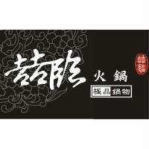 for hot pot restaurants, Japanese cuisine restaurants, cafeterias, eating houses, restaurants, etc.: As "火鍋" ("hot pot") is a generic term of the designated services and "極品鍋物" ("supreme foods for hot pot") is widely used by restaurants to describe the quality of the designated services (meals), no disclaimer was made.
- 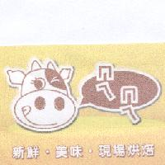 for toast, bread, cakes, hamburgers, etc.: The terms "新鮮" ("fresh") and "美味" ("tasty") are descriptive of the quality of the goods and "現場烘焙" ("baked on-site") is to emphasize that these goods are baked on site. As these are widely used by bakery traders, no disclaimer was made.
- "高倫雅芙除痘系列" for skin cleaners, skin moisturizers, tonic lotions for skin, etc.: As "除痘系列" is descriptive of the applications of the goods and is commonly used by relevant traders of skin cleaning and care products, no disclaimer was made.
- 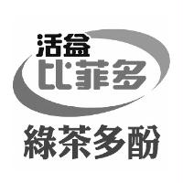for milk, lactic acid bacteria beverages, soy milk, etc.: As "綠茶多酚" is descriptive of the ingredients of beverages and is commonly used by beverage traders, no disclaimer was made.
- 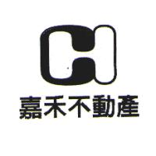 for lease and sale of all kinds of real estate, purchase and sell of real estate, lease intermediary services, etc.: As "不動產" ("real estate") is descriptive of the designated services (services relating to real estate) and is commonly used by the real estate industry, no disclaimer was made.
- 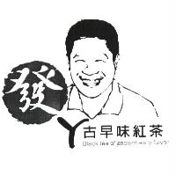 for eating houses, cold and hot beverage shops, etc.: As "古早味紅茶" and its English translation "BLACK TEA OF ANCIENT EARLY FLAVOR" are both descriptive of the features of drinks provided under the services and are commonly used by beverage stores, no disclaimer was made.
- 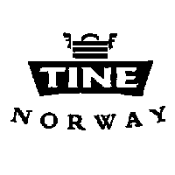 for meat, fish fillet, poultry and games (not live) originating from Norway: As "NORWAY" is the name of a country, it is obviously descriptive of the place of origin or the source of the designated goods. Therefore, no disclaimer was made.
• 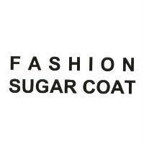 for wallets, leather bags, purses, backpacks, school satchels, fanny packs, etc.: As "FASHION" is descriptive of the features of the designated goods and is frequently used to emphasize the fashion style of goods by traders of make-up, care products, leather bags, shoes, jewelry, clothing and accessories, no disclaimer was made.
- 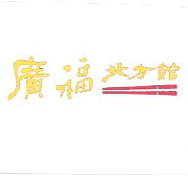 for restaurants, cold and hot beverage stores, snack bars, etc.: As "北方館" is descriptive of the features of goods offered by the designated services and is commonly used by restaurants, no disclaimer was made.
•  for cars and motorcycles, wheel rims, car frames, etc.: As "TECH" is the abbreviation of "TECHNOLOGY" and "FOR PROFESSIONALS" means to be used by professional personnel, the entire term is obviously descriptive of the quality and characteristics of the goods and is commonly used by competitors and the public to describe cars and motorcycles. Therefore, no disclaimer was made.
• "蠻牛第二代" for Chinese and western medicines, refreshing pharmaceutical preparations, nutritional preparations for medical supplements, etc.: As "第二代" ("second generation") is obviously descriptive of the quality and features of the goods and is commonly used by competitors and medical professionals to describe pharmaceutical preparations, no disclaimer was made.
- 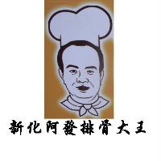 for snack shops, pedal food stands, restaurants, etc.: The term "新化" ("Xin-Hua"), a geographic name in Tainan, is obviously descriptive of the place where relevant services are provided, while "排骨大王" ("rib king"), a combination of the content of services and the Chinese "king," is a self-laudatory term. Since such mark is descriptive of the quality and features of the goods offered by the designated services and is commonly used by restaurants, no disclaimer was made.

(2) Situations in which a disclaimer is required
Where words are descriptive of the goods or services but are rarely used by competitors and the public to describe the designated goods or services, doubts can easily arise in respect of the scope of trademark rights because it is not for sure whether the trademark owner has acquired the exclusive right to use such words, a disclaimer should be made. Where descriptive words are in a foreign language, even if such words are commonly used by foreign competitors and the public to describe the designated goods or services, there may still be doubts over the scope of trademark rights because they are rarely used by local competitors and the public. In consequence, a disclaimer should be made.

Accepted examples:
- "旁氏甜橙沁香" ("Pond's sweet orange fragrance") for soaps both for human use and not for human use, cleaning preparations both for human use and not for human use, perfumes, etc.: As "甜橙沁香," which means refreshing fragrance of sweet oranges, is descriptive of the fragrant features of the designated goods but is seldom used by competitors and the public, a disclaimer was made.
- 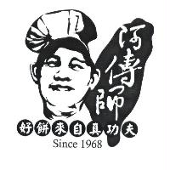for wu-ren short cakes, nougats, moon cakes, etc.: "SINCE 1968," which signifies the year when the business was first created, is extensively used by all industries and is not distinctive, and therefore, no disclaimer was made. On the other hand, the phrase "好餅來自真功夫" ("good cakes are made by genuine skills") means the solid and genuine skills for making cakes and is descriptive of the quality and features of the goods, but such phrase is rarely used by competitors and the public in connection with bakery products. Therefore, a disclaimer was made.
-  for disinfecting and sterilizing solutions for medical apparatus and instruments: As "PROTECTING LIVES AGAINST INFECTION" is descriptive of goods sterilization to avoid infection and is seldom used by competitors and the public to describe the designated goods, a disclaimer was made.
- "活霸益菌王" for nutritional supplements of lactic acid bacteria, nutritional supplements of enzyme, etc.: The term "益菌王" ("probiotics king"), a combination of the ingredients of the goods and the Chinese character "王," is a self-laudatory term and is descriptive of the quality and professional nature of the designated goods. Since such term is seldome used by competitors for lactic acid products, a disclaimer was made.
• 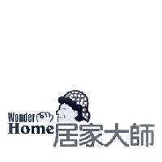 for cleaning agents other than for human body, floor polishing wax, polishing wax for cars, etc.: "大師" ("master") is a self-laudatory term, while "居家大師" ("home master") refers to professionals who handle daily domestic affairs and is descriptive of the quality and professional features of the designated goods. Since such term is seldom used by competitors and the public to describe the designated goods, a disclaimer was made.
• 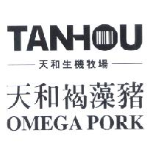 for meat, meat products, jerky, etc.: As "生機牧場" ("organic ranch") is obviously descriptive of the raw materials (pigs) of the designated goods, but is seldom used by competitors and the public, a disclaimer was made. In addition, the Chinese term "褐藻豬" ("he-zao pigs") is descriptive of the feedstuff formula for the raw materials (pigs) of the goods, but is seldom used by competitors and the public. As "褐藻豬" is also used by the applicant to emphasize the features of the goods, a disclaimer was made in order to avoid doubts in respect of the scope of the trademark rights. The term "OMEGA PORK," which means pork containing OMEGA fatty acid (in particular, OMEGA-3 fatty acid), is directly descriptive of the pork, but is seldom used by local traders and the public. To avoid any doubts in respect of the scope of the trademark rights, a disclaimer was made.

When words describe features of the goods or services in a simple and straightforward manner, they are deemed direct and obvious descriptions of the goods or services. If the descriptive nature of such words is so obvious that the trademark owner and competitors will not consider that element to be covered by the scope of trademark rights, then no disclaimer would be necessary even if such words are not frequently used by competitors and the public to describe the designated goods or services.

Accepted examples:
- 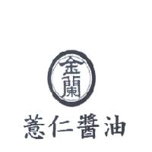for soy sauce: "薏仁醬油" ("Coix seed soy sauce") describes the raw material for the designated goods in a simple and straightforward manner, and is deemed as direct and obvious descriptions of the goods or services. As the descriptive nature of the term is so obvious, even though it is rarely used by competitors and the public to describe soy sauce, no disclaimer was made.
• 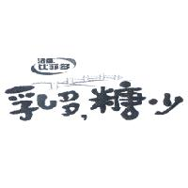 for milk, lactic acid bacteria beverages, soy milk, etc.: "乳多 糖少" ("more milk less sugar") describes the ingredients of the designated goods in a simple and straightforward manner, and is deemed as direct and obvious descriptions of the goods or services. As the descriptive nature of the term is so obvious, even though such term is seldom used by competitors and the public to describe beverages, the trademark owner would not consider that the rights relating thereto could have been acquired; therefore, no disclaimer was made.
• 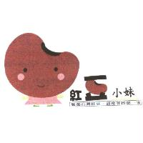 for red bean soup, mung bean soup, peanut soup, sweet potato soup, etc.: Both "嚴選台灣紅豆" ("specially selected Taiwan-grown red beans") and "甜度管控第一家" ("the first to control sweetness") describe the quality of raw materials of the designated goods and the features of these goods in a simple and straightforward manner and are deemed as direct and obvious descriptions of these goods or services. As the descriptive nature of the terms is so obvious, even though they are rarely used by competitors and the public to describe these goods, no disclaimer was made. (PS. 1. 紅豆正確名稱為 “Azuki beans”； “red bean”實為誤用，然已廣泛使用。2. 綠豆不是 “green beans”。)

3.1.2 Generic terms
A generic term is normally used by traders as the term of specific goods or services. In general, a generic term is not distinctive, but is an industry consensus. Therefore, the inclusion of a generic term into a trademark is unlikely to give rise to any doubts over the scope of trademark rights. The applicant is not required to state that he/she disclaims any exclusive right to such element.

Accepted examples:
-  for toy masks, toy figures, puppets, fabric figures, dolls, etc.: As "TOY" is a generic term of the designated goods, no disclaimer was made.
- 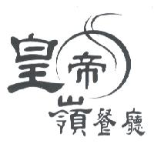 for restaurant services: As "餐廳" ("restaurant") is a generic term of the designated services, no disclaimer was made.
- 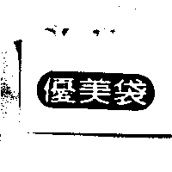 for paper bags: As "袋" ("bag") is a generic term of the designated goods, no disclaimer was made.

3.1.3 Other non-distinctive words
Descriptions relating to the applicant's business such as the year of incorporation, the type of enterprise and its trade name, and surnames, company names, domain names, non-descriptive slogans, conventional greeting phrases, auspicious phrases, popular terms and idioms are all deemed as non-distinctive words. Determination of whether a disclaimer should be made is based on the following principles:

(1) Circumstances where no disclaimer is required
Because the following words are normally used to describe the applicant's business and are extensively used by the relevant industries, they, in principle, are unlikely to give rise to any doubts as to the scope of the trademark rights. Therefore, no disclaimer is required.

year of incorporation; words signifying brand such as "牌" ("pai") and "brand"; type of an enterprise such as "股份有限公司" ("company limited by shares") or "有限公司" ("limited company"); words signifying part of a store name such as "齋" ("zhai"), "堂" ("tang"), "記" ("ji"), "行" ("hang"), "社" ("she") and "號" ("hao")"; words signifying a group of multiple entities such as "集團" ("group"); words signifying the nature of an enterprise such as "工業" ("industry") and "商事" ("commerce"); generic terms signifying a business organization such as "企業" ("qi-ye"), "實業" ("shi-ye"), "展業" ("zhan-ye") and "興業" ("xing-ye"); words signifying the nature of business such as "建設" ("construction"),"銀行" ("bank"), "電腦" ("computer") and "通訊" ("communication"); common elements of a domain name, such as "tw" and "jp" signifying country codes and "com," "org," "edu" and "net" signifying nature of a domain name; and words signifying a provider, store or place such as "屋" ("house"), "家" ("house"), "館" ("hall"), "軒" ("shop"), "庭" ("booth"), 鋪(pronounced as "Pu," from Japanese "honbo"??? How about simply “shop”?), "店" ("store"), "坊" ("house"), 工房("working house"), 工場 ("working site"), 會館 ("gallery"), 天地("world"), 廣場 ("plaza"), 事務所 ("office") and 旗艦店("flagship").

Accepted examples:
• 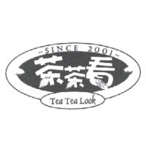for beer, lotus root tea, ginseng tea, milk tea, chrysanthemum tea, etc.: As "SINCE 2001" refers to the year when the enterprise was founded, no disclaimer was made.
• 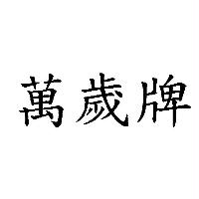 for all kinds of animal milk, flavored milk, lactic acid bacteria drinks, powered milk, etc.: As "牌" ("pai") means a brand, no disclaimer was made.
• 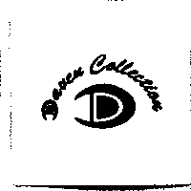 for shoes: As "COLLECTION," which means gathering, selection or collectibles, is widely used in different fields of goods, no disclaimer was made.
• 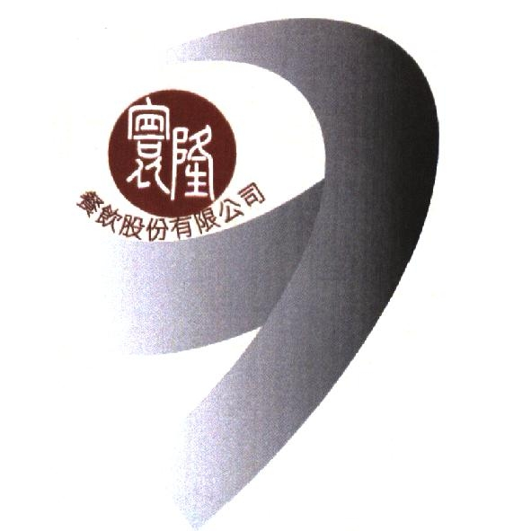for restaurants, hotels, etc.: As "餐飲股份有限公司" ("dinning co., ltd.") is descriptive of business and type of company, no disclaimer was made.
- "雄記" for cold and hot beverage stores, eateries, cafes, etc.: As "記" ("ji") is commonly used to signify the name of a store, no disclaimer was made.
• 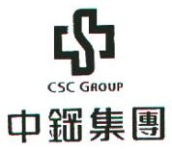 for industrial chemicals, scientific chemicals, chemical reagents, etc.: As "GROUP" and "集團" ("group") are commonly used to signify an organization comprised of multiple business entities, no disclaimer was made.
• 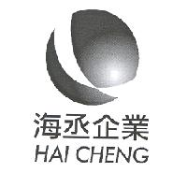 for import/export agency services: As "企業" ("enterprise") is a generic term of business organization, no disclaimer was made.
• 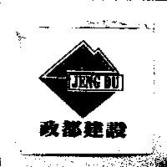 for tea, black tea, green tea, qing tea, etc.: As "建設" ("construction") is merely part of a company name signifying the type of business, no disclaimer was made.
• 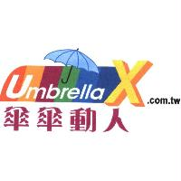 for umbrellas: As ".com.tw" is part of a domain name commonly used by general business organizations in Taiwan, the word "Umbrella" is a generic term of the designated goods, and the "umbrella design" is a realistic picture of the designated goods, no disclaimer was made.
• 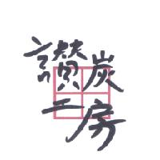 for non-fuel charcoal for cooking, bamboo charcoal material, etc.: As "工房," which means working house, is commonly used for various kinds of goods and services, no disclaimer was made.
- 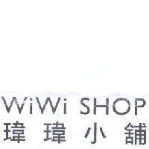 for clothes, pants, scarves, kerchiefs, etc.: As "小鋪" and "SHOP," which both mean shop or store, are commonly used for various kinds of goods and services and signify stores that offer the designated goods or services, no disclaimer was made.

(2) Elements to be disclaimed for exclusive right to use

I. Surnames and combinations of a surname and title
As found in domestic trademark examination practices, an applicant is inclined to include a surname in a trademark. Considering that competitors may also wish to use their own surnames, a surname cannot be exclusively monopolized by anyone alone. To avoid doubts arising from the inclusion of a surname by trademark rights, a disclaimer should be made. For a combination of a surname with "氏" ("shi"), "家" ("jia"), "記" ("ji") or a title, since such combination still means a surname, a disclaimer should also be made. If a combination of a non self-laudatory title with the name of goods or services merely signifies the provider of the goods or services, it should be deemed as having no distinctiveness. To avoid doubts arising from the scope of the trademark rights, a disclaimer should be made.

Accepted examples:
• 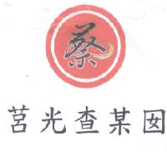 for leaf-packed rice dumplings, leaf-packed cereal dumplings, leaf-packed rice dumplings with peanuts, vegetarian rice dumplings, etc.: As "蔡" ("cai") is a surname, a disclaimer was made.
- 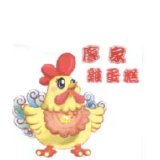for food stalls, mobile food stalls, etc.: As "雞蛋糕" ("egg cake") is obviously descriptive of the goods provided by the designated services, no disclaimer was made. As "廖家" means "the Liao," a disclaimer was made.
- 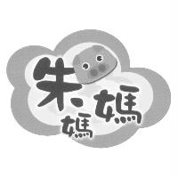 for snack bars, food stalls, Japanese cuisine restaurants, etc.: As "朱媽媽" ("mother Chu") is a respectful title for women with the surname "Chu," it still denotes a surname; therefore, a disclaimer was made.
- 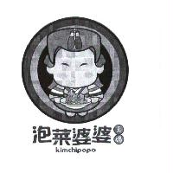 for dried fruits and vegetables, glacé fruits and vegetables, pickle, kimchi, etc.: As "王媽" ("mother Wang") still means a surname, a disclaimer was made. Because "泡菜婆婆" ("grandmother kimchi") means a senior woman who is an expert in preserving kimchi, a disclaimer was made.

II. Company names and domain names
In practice, it is very common for an applicant to protect his/her company name and domain name by registering them as trademarks. However, a non-stylized company name or domain name that is not distinctive will be perceived by consumers to identify the business entity or the website adress rather than to serve as a sign identifying the source of goods or services. Therefore, neither a company name nor a doamin name can be protected under the Trademark Act. To avoid doubts arising from the effect of trademark rights relating thereto, a disclaimer should be made.

Accepted examples:
• 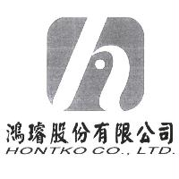 for pulse generators, LCDs, encoders, etc.: As "鴻璿股份有限公司" and "HONTKO CO., LTD." are the applicant's Chinese and English company names, a disclaimer was made.
• 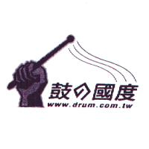for provision and introduction of music information via the Internet: A disclaimer was made in respect of the domain name "www.drum.com.tw."

III. Slogans and conventional greetings, auspicious phrases, popular terms or idioms
A slogan may or may not refer to the quality, use, raw material, place of origin or relevant features of goods or services. Generally speaking, a slogan is not deemed distinctive because consumers will not consider it as a sign that identifies the source. However, when a slogan is created by an applicant or is a word combination that is seldom used by competitors, which may give rise to doubts as to whether the trademark owner has acquired trademark rights in respect of that element, a disclaimer should be made. Also, domestic trademark applicants are more inclined to include a conventional greeting, auspicious phrase, popular term or idiom in a trademark. Those phrases or terms may not be descriptive of the goods or services but may be used by competitors for their respective goods or services. To avoid doubts relating to the scope of trademark rights, a disclaimer should be made.

Accepted examples:
• 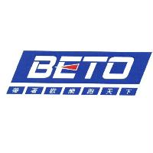 for wrenches, screw wrenches, screwdrivers, etc.: The slogan "帶著歡樂跑天下" ("to travel around the world with joy") was disclaimed for exclusive right to use.
• 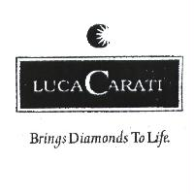 for jewelry accessories, precious metals, etc.: As the slogan "BRINGS DIAMIONDS TO LIFE" is self-explanatory, a disclaimer was made.
•  for data carriers recording computer programs, optical data carriers recording computer programs, etc.: As the slogan "Enjoy your life" is self-explanatory, a disclaimer was made.
• 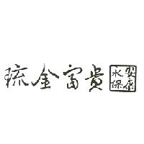 for crystal decorations, glass decorations, ceramic decorations, etc.: As "永保安康" ("be healthy and safe forever") is a conventional blessing, a disclaimer was made.
• 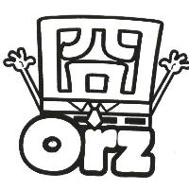 for underwear, night clothes, sweat shirts, swimsuits, shirts, shoes, boots, etc.: As "囧" and "orz" are both popular terms, a disclaimer was made.

IV. Religious and folk belief terms
If a religious and folk belief term is not used as descriptions relating to the goods or services, such use will give consumers the impression that it is merely a general prayer or decorative character(s), and cannot serve to identify the source of the goods or services. Therefore, such term is not distinctive. However, if such term is seldom used by the relevant industries, because whether or not the trademark owner has acquired the trademark rights in that element will easily give rise to doubts and some competitors of the same trade may also wish to use the same term on their own goods or services, to avoid any doubts over the scope of trademark rights, a disclaimer should be made.

Accepted examples:
•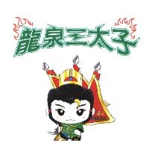 for beer, black beer, draught beer, light beer, ginger beer, etc.: As "三太子" ("Nalakuvara") is the name of a deity rather than a description of the designated goods, it is not distinctive. Therefore, a disclaimer was made.
• 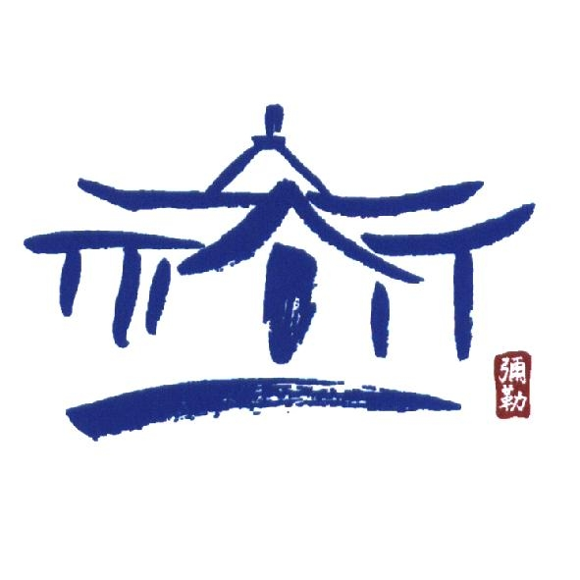 for clothing, shoes, scarves, kerchiefs, etc. and newpaper offices, news agency, information bureaux, etc.: As "彌勒" ("Maitreya") is the name of a deity, rather than a description of the designated goods, it is not distinctive. Therefore, a disclaimer was made.

As to terms commonly used in religion and folk belief such as the name of a deity, spells, mantras, text from religious books or the name of Buddha for "incense coils and incense powder" in Class 0309, "candles, candle wicks" in Class 0405, "joss paper, fake gifts of paper as sacrifices to the gods" in Class 1604, "incense burners, incineration burners for joss paper, candle holders, incense lighters" in Class 2110, "retail and wholesale of funeral and religious articles" in Class 3519, "funeral services" in Class 4504 and "planning of religious gatherings" in Class 4513 according to the Table of Classification of Goods and Services, they are often used by the traders in the same industry and are directly and obviously descriptive of the designated goods or services. In principle, these terms will not give rise to any doubts over the scope of trademark rights. Therefore, no disclaimer is required. However, where terms used in religion and folk belief are merely descriptive of some of the designated goods or services and are not distinctive in respect of the remaining goods or services, the terms should still be disclaimed for exclusive right to use in order to avoid disputes over the scope of trademark rights.
Accepted example:
• 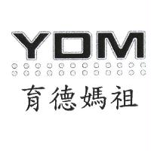 for fortune telling, aspect astrology, divination, geomantic omen, organization of religious ceremonies for the deceased, arrangement of religious conferences, etc.: As "媽祖" ("Mazu") is the name of a deity, its use in connection with "organization of religious ceremonies for the deceased, arrangement of religious conferences" is descriptive of the content of the services, while its use in connection with fortune telling, aspect astrology, divination and geomantic omen is deemed non-descriptive. Therefore, "媽祖" was disclaimed for exclusive right to use.

3.1.4 For stylized words, a disclaimer of the non-stylized original form should be made if such original form is likely to give rise to doubts as to the scope of trademark rights.
A non-distinctive word which in its original form is not registrable may be granted registration if it is designed in such a way that it no longer gives the impression of being a purely descriptive or non-distinctive word or a generic term and becomes distinctive. Nevertheless, the exclusive right to use granted by registration does not cover the non-stylized original form of the word. Therefore, the applicant may not exclude any third party's use of such word. If a non-stylized word in its original form is not distinctive, the trademark owner may not exclude another party's use of such word. For instance, in trademark examples in connection with restaurant services, in which the trademarks contain "餐廳" ("restaurant") or the surname "蔡" ("cai"), the non-stylized "餐廳" and "蔡" for the designated services are not distinctive, so the trademark owner cannot exclude another's use of those terms. As for the former example, it is without doubt that the trademark owner cannot exclude another's use of "餐廳" for restaurant services and therefore, no disclaimer was made. As the latter example may give rise to doubts over whether the trademark owner may exclude another's use of "蔡," a disclaimer was made in order to specifically define the protective scope of the trademark. In conclusion, for stylized words, they may be registered after a disclaimer of the non-stylized original form is made if such original form is not distinctive and is likely to give rise to doubts over the protective scope of the trademark.

Before 1 January 2010, the phrase "未經設計" ("non-stylized") was used to disclaim non-stylized words on the grounds that the trademark owner should have exclusive right to use the stylized words. However, what would constitute as "stylized" has been hotly debated. Moreover, determination of a likelihood of trademark confusion relies on the observation of the trademark as a whole regardless of how stylized the words are. In other words, even if a non-stylized word is disclaimed for exclusive right to use, it will not affect the determination of a likelihood of confusion. Therefore, the Guidelines no longer uses the phrase "未經設計." No matter how stylized a word is, the subject of a disclaimer is always its non-stylized original form. In addition, the disclaimer should include a "word" description, which specifically states the elements to be disclaimed being the non-stylized original words.

The following accepted cases were amended according to the standard form of disclaimer provided in the Guidelines. Please refer to Section 6 on the Guidelines for the standard form of disclaimer.

Accepted examples:
- 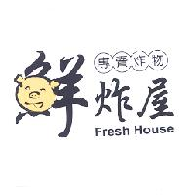for eateries, snack bars, etc.: "鮮炸屋" ("house of freshly fried foods"), "專賣炸物" ("specializing in fried foods") and "Fresh House" are all descriptive of the quality and features of the goods offered through the designated services. Among them, "專賣炸物" is commonly used by competitors and the public, so no disclaimer was made, while the non-stylized "鮮炸屋" and "Fresh House" are not frequently used by competitors, so a disclaimer was made; no claim is made to the exclusive right to use the words "鮮炸屋" and "Fresh House" apart from the trademark as shown.
-  for cured meat, meat jerky, beef jerky, pork jerky, etc.: As "高" ("gao") is a surname, a disclaimer for exclusive right to use was made; no claim is made to the exclusive right to use the word "高" apart from the trademark as shown.

• 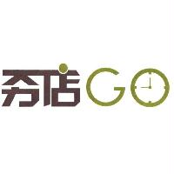 for cyber shopping, mail order services and Internet auction services, etc.: As "夯店" ("popular store") is a popular term, a disclaimer for exclusive right to use was made; no claim is made to the exclusive right to use "夯店" apart from the trademark as shown.
• 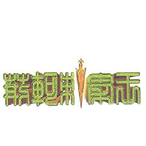 for computer software, optical data carriers recording computer game programs, etc.: "荊軻刺秦王" (Jing Ke’s assassination attempt of the King of Qin) is a famous historical event in mainland China and is descriptive of the background or storyline of computer games. Because this it is rarely used by other competitors, a disclaimer was made; no claim is made to the exclusive right to use the phrase "荊軻刺秦王" apart from the trademark as shown.

3.1.5 When an incorrect word is deliberately used and its correct form is likely to give rise to doubts in respect of the scope of trademark rights, the correct form should be disclaimed.
A non-distinctive word in a trademark may be deliberately replaced with a homophone or uncommon word. In cases involving foreign words, a word may be deliberately replaced with a homophone or a misspelled word. If consumers can recognize it, and if such word still gives consumers an impression of being descriptive or non-distinctive or being a generic term as the correct word conveys, the relevant trademark may be registered only after a disclaimer of the word in the correct form is made. Although competitors may not use the incorrect form, they may still wish to use the word in its correct form and doubts may arise in respect of the scope of trademark rights in the correct form. A disclaimer should therefore be made; no claim is made to the exclusive right to use the word "the correct word/spelling" apart from the trademark as shown.
To illustrate a disclaimer of the word in the correct form, the following examples are provided, in which the disclaimers have been amended according to the standard form of disclaimer specified in the Guidelines. Please refer to Section 6 on the standard form of disclaimer.
Accepted examples:
- "東山補愲精" for powdered milk, low-fat powdered milk, etc.: "補骨精" ("bone-nourishing essence") is the correct form of "補愲精" and is descriptive of the function of the designated goods, but "補骨精" is not frequently used by competitors. Therefore, a disclaimer was made; no claim is made to the exclusive right to use the word "補骨精" apart from the trademark as shown.
-  for digital video discs, blue-ray discs, high-resolution digital discs, etc.: "SecurDisc" is a misspelling of "SECURE DISC," which directly describes the encryption nature of the goods. Therefore, no disclaimer was made.

If a homophone gives consumers a novel and unique impression and serves to denote and distinguish the source of goods or services, no disclaimer of the non-distinctive element of the word needs to be made (refer to Section 4.2 of the Guidelines).

3.1.6. Disclaimer involving foreign words
When foreign words in a trademark are directly and obviously descriptive of the goods or services or are generic names, those who understand the words would know that the trademark owner has not acquired exclusive right to use the words, but those who do not understand the words cannot judge whether the trademark owner has acquired exclusive right therein because they could not know the meaning of such words. Therefore, a disclaimer must be made because that element in the trademark could give rise to doubts as to the scope of the trademark rights. Most locals are familiar with English, and competitors can understand the meanings of English words to certain extent. Therefore, judgment of the scope of trademark rights of English words may follow Section 3.1 of the Guidelines (non-distinctive words). As for foreign languages other than English, since they are not commonly understood by locals, to avoid the situation in which competitors are unsure about the scope of trademark rights of those foreign words because they do not know the meanings thereof, a disclaimer should be made as long as the foreign words are not distinctive (see Section 6.5 of the Guidelines for forms of disclaimer).

Accepted examples:
• 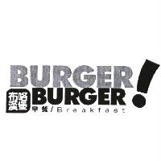 for breakfast bars, restaurants, cold and hot beverage stores, etc.: "BURGER" and "Breakfast" refer to specific meanings and are directly and obviously descriptive of the services content, so no disclaimer was made.
• 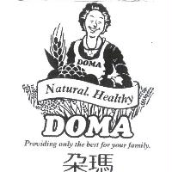 for retail and wholesale of agricultural products and beverages: "Natural" and "Healthy" have specific meanings and are directly and obviously descriptive of the services content, so no disclaimer was made. On the other hand, as "PROVIDING ONLY THE BEST FOR YOUR FAMILY" is self-explanatory and is not distinctive, a disclaimer was made; no claim is made to the exclusive right to use "PROVIDING ONLY THE BEST FOR YOUR FAMILY" apart from the trademark as shown.
• 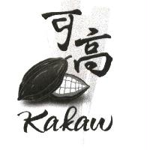for chocolate cake, chocolate powder, chocolate paste, etc.: As the "cocoa bean design" is a realistic picture of cocoa beans and is often used by chocolate-related industries, no disclaimer was made. "kakaw" is cocoa in Filipino and is descriptive of the ingredients of the goods, so it is not distinctive. Considering that Filipino is not commonly understood by locals, to avoid doubts relating to the scope of trademark rights in such word, a disclaimer was made; no claim is made to the exclusive right to use the word "kakaw" which means "cocoa" in Filipino apart from the trademark as shown.
• 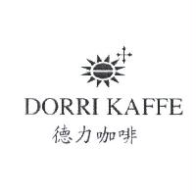 for coffee, coffee beans, instant coffee, coffee-based beverages, etc.: As "咖啡" ("coffee") is a generic term and is descriptive of the ingredients of the designated goods, no disclaimer was made. Because "KAFFE," which is "coffee" in German, is a generic term and is descriptive of the ingredients of the designated goods, it is not distinctive. Considering that German is not commonly understood by locals, to avoid doubts relating to the scope of trademark rights in such word, a disclaimer was made; no claim is made to the exclusive right to use the word " KAFFE" which means "coffee" in German apart from the trademark as shown.

3.2 Non-distinctive designs
Non-distinctive designs include descriptive designs relating to goods, generic marks, designs relating to religion and folk belief (other than showing the important features of the goods or services), decorative patterns of goods, appearance of goods and packaging design of goods, etc. Examples of disclaimer are given below:

3.2.1 Descriptive designs
Descriptive designs include the shapes of goods, designs showing the important features of goods, designs commonly used within the industry to describe the goods or services, and geographic designs indicating places of origin of goods or services, and/or places where goods or services are provided, or other features of the goods or services, etc. When the design of a trademark to be registered is a picture of the actual object or a drawing of the object, especially a realistic design which is obviously not stylized, or the contour of a geographic region, it is deemed non-distinctive. Because such design is clearly descriptive of the nature of the goods or services and competitors frequently use similar designs, there would be no doubt over the scope of trademark rights. Therefore, no disclaimer should be made.

(1) Shapes of goods
Accepted examples:
• 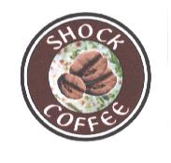for coffee, coffee beans, coffee packs, etc.: As the design of the trademark, which is a picture of coffee beans, is explicitly descriptive of the designated goods or their raw material, no disclaimer was made.
• 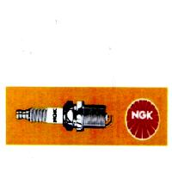 for starters for internal combustion engines and their parts and fittings, namely, spark plugs, pre-heat plugs and spark plug caps for internal combustion engines, etc.: As the "spark plug design" is a picture of the designated goods, no disclaimer was made.
• for fresh fruits, fresh vegetables, tangerines, persimmons, plums, peaches, pears, etc.: As the "pear design," the "orange design" and the "persimmon design" are realistic drawings of some of the designated goods, no disclaimer was made.

When a design showing the shape or goods is not commonly used by competitors, such as cookies in the shape of aquatic creatures or porker designs, because doubts may arise from whether the pictures of cookies in the shape of squids, fish or sea stars, "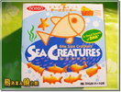," and the realistic drawings of spade, heart, diamond and club, "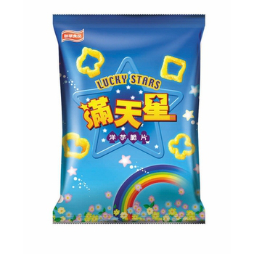," have acquired trademark rights, a disclaimer should be made. However, it is often the case that a product packaging design is also applied for registration as a trademark. The disclaimer to be made should refer to Section 6.3 of the Guidelines.

(2) Designs commonly used in relevant industries to describe goods or services

Accepted examples:
• 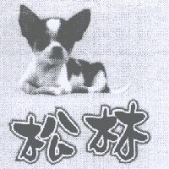 for retail of pet toys, retail of pet clothing, retail of cat and dog bath gels, etc.: As the pet service industry often uses a lovely animal picture to signify the services it provides in order to attract consumers, no disclaimer was made in respect of the realistic picture of a dog.
• 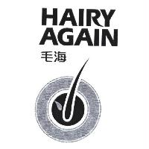 for hair creams, hair lotions, hair care preparations, hair care creams, etc.: As the "hair follicle design" is frequently used on hair cleaning and care products, no disclaimer was made.
• 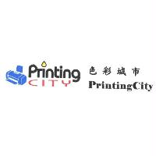 for ink toners for printers, carbon toners for printers, etc.: As "Printing" is descriptive of the function of the goods and as the "printer design" is commonly used to describe the goods relating to printers, no disclaimer was made.
• 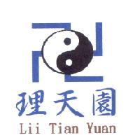for conducting of religious script chanting and religious ceremonies for the deceased, religious ceremonies, funeral services, etc.: As the symbol "卍" and the "Taiji design" are religious signs commonly used by people of this country, the use of such combination for the designated services obviously signifies the provision of services according to the teachings or rituals of a specific religion. Therefore, no disclaimer was made.

(3) Geographic designs relating to geographic origin or other features of goods or services

Accepted examples:
• 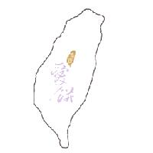for milk crisps, sun cakes, moon cakes, etc.: As the "Taiwan design" and "台灣" ("Taiwan") in the trademark both refer to the place of origin of the goods and "餅" ("biscuit" or "cake") is a generic term of the designated goods, no disclaimer was made.
• 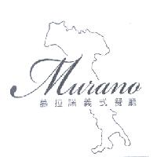 for cafes, coffee shops, snack bars, cafeterias, etc.: As "義式餐廳" ("Italian restaurant") and the "Italy design" of the trademark are commonly used by restaurant traders, they are explicitly descriptive of the cuisine that the designated services offer; therefore, no disclaimer was made.
• 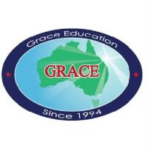 for applying for admission to foreign colleges and universities for others, provision of admission information and news for foreign colleges and universities for others, etc.: "Education" simply denotes the type of business; "since 1994" signifies the year in which the business was founded; and the "map of Australia," which means that the applicant mainly handles admission to Australian schools and provides admission information relating thereto, is descriptive of the features of the services. Therefore, no disclaimer was made.

3.2.2 Generic marks
As a generic mark means a mark commonly used by the industry of the specific goods or services, it is generally deemed non-distinctive. What constitutes as non-distinctiveness of a generic mark would be based on industry consensus. Therefore, the inclusion of a generic mark in a trademark shall be unlikely to give rise to doubts as to the scope of the trademark rights, and the applicant is not required to disclaim exclusive right to such element.

Accepted examples:
- 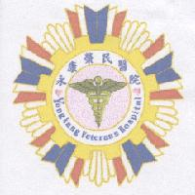for hospitals, all kinds of pathologic examinations, provision of biochemical examinations, pharmaceutical consultation, etc.: As the Caduceus design is a symbol of medicine that is commonly used all over the world, no disclaimer was made.
- 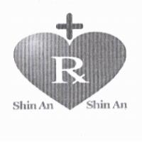 for retail of medicines, retail of cosmetics, retail of medical apparatus, etc.: As the symbol "Rx," which is a prescription sign for the medical industry, is commonly used by pharmacies to denote the provision of medicine dispensing services, and the "medical cross design" is a common sign for the medical industry, no disclaimer was made for both.
• 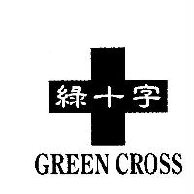 for surgical caps, medical beds, dropping bottle holders, medical gloves, etc.: As the "medical cross design" is commonly used by the medical industry, no disclaimer was made.

3.2.3 Other non-distinctive designs

(1) Religious signs and folk belief signs
The use of a religious or folk belief sign for goods or services gives the impression of protection, blessing, auspice and prayers. Generally speaking, such sign is deemed an element having no distinctiveness, so no disclaimer is required. However, considering that religious deities may have different forms or may be depicted by different methods, the applicant and competitors may not ascertain whether the depiction of the subject trademark is eligible to acquired trademark rights. To avoid any doubts, a disclaimer should be made.

Accepted examples:
- 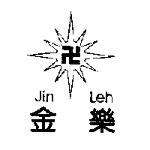 for metal ladders, metal folding ladders, joint ladders, etc.: As "卍"is a Buddhist symbol, it is not related to the designated goods but instead, gives consumers the impression of protection, blessing, auspice and prayers. Therefore, no disclaimer was made.
- 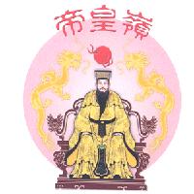 for funerary services, funeral chapel decoration, funeral homes, cremation, etc.: As the entire trademark, which features a statute of a deity and twin dragons flanking a pearl (sun), implies auspice and prayers for the blessing of the gods, whether such design should be covered by the scope of trademark rights is doubtful. Therefore, a disclaimer was made.

(2) Decorative patterns, appearance and packaging design of goods
The decorative pattern, appearance or packaging design of goods is normally not used as a sign that identifies the source of the goods or services. Such decorative pattern, appearance or packaging design can acquire distinctiveness only through use. However, considering that such decorative pattern, appearance and packaging design may be independently depicted or designed by the applicant and competitors may not use the same decorative pattern, appearance or packaging design, there may be doubts relating to whether the trademark owner and competitors have exclusive right to that element; therefore, a disclaimer should be made.

Accepted examples:
- 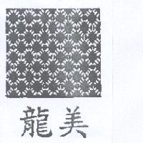 for board game sets, playing cards, etc.: As the design of the trademark is a common decorative pattern appearing on the back side of playing cards, a disclaimer was made.
- 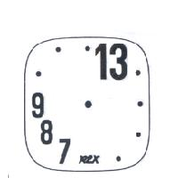 for clocks, watches, wrist watches, calendar watches, etc.: As the design of the trademark is a watch face pattern, to avoid doubts arising from the exclusive right thereto, the applicant disclaims any exclusive right to the "watch face digit design."
- 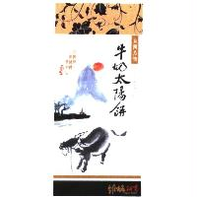 for sun cakes, milk sun cakes, various cookies, etc.: The design is the packaging pattern of the goods and "維格" ("wei ge") and "vigor" cannot denote the source of the goods, while the other Chinese terms and designs are not distinctive. To avoid doubts arising from the acquired trademark rights thereto, the applicant disclaims any exclusive right to the Chinese terms/designs other than "維格" ("wei ge") and "vigor."

3.3 Non-distinctive elements such as numbers, signs and model numbers
In addition to words and designs, a trademark often contains numbers, signs and model numbers. When a number, musical symbol, punctuation, mathematic symbol or unit symbol is used to describe aspects of the goods or services, generally speaking, it obviously has descriptive nature. Therefore, no disclaimer is required since the inclusion of that element in the trademark could not give rise to doubts as to the scope of the trademark rights.

Accepted examples:
-  for motorcycles and their parts and fittings: As "125" of the trademark is descriptive of the displacement specifications of the designated goods, no disclaimer was made.
- 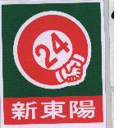 for convenience stores, retail of agricultural, livestock and aquatic products and retail of foods and beverages: As "24" of the trademark denotes the time during which it provides relevant services, no disclaimer was made.
- 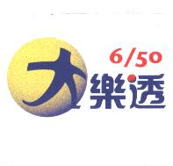 for launch of public welfare lottery: As "6/50" of the trademark denotes the method of purchasing public welfare lottery (each bid consists of 6 numbers and costs NT$50), no disclaimer was made.
- "EPASMIN - Ω3" for Chinese and western medicines, nutritional supplements, etc.: As "Ω3" is descriptive of the ingredients of nutritional supplements, no disclaimer was made.
- "KYRO II" for computer hardware and integrated circuits, namely, plotter accelerators: As "II" is normally used to signify the new generation of IT products, no disclaimer was made.
- 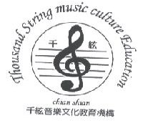 for music instruments, performance assisting devices, Chinese and western music instruments, etc.: As "音樂文化教育機構" ("music and culture educational institute") and "music culture Education" both signify the type of business and the treble clef and the stave are signs commonly used for music instruments or by the musical teaching industry, no disclaimer was made.
- 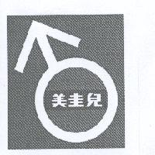 for calcium tablets, nutritional supplements containing calcium, Chinese medicines, western medicines, etc.: As  is a symbol of the male gender, it is obviously descriptive of the goods; therefore, no disclaimer was made.
• 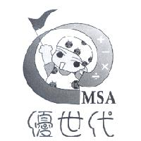 for printed matter, periodicals, books, publications, workbooks, etc.: As "＋－×÷" are symbols commonly seen in mathematic books or periodicals or teaching materials, no disclaimer was made.
- 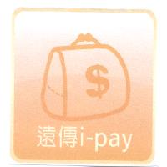 for provision of payment collection services, bill payment services and electronic fund transfer via telecommunications toll collection system, etc.: As ＄ is a symbol commonly used to describe services relating to cash flow, no disclaimer was made.

When a number included in a trademark is not descriptive of the goods or services but is not distinctive, to avoid doubts arising from whether the scope of trademark rights cover that number, a disclaimer should be made. As noted, a model number is not a generic specification commonly used by the industry, but instead, is normally used by one enterprise to identify different series of goods it provides. As general consumers will not use a model number to identify the source of goods, model numbers are not distinctive. Therefore, when a trademark includes a model number, to avoid doubts arising from whether the scope of trademark rights covers the model number, a disclaimer should be made.

Accepted examples:
- 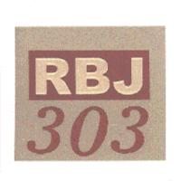 for denim shirts, jeans, clothes, vests, etc.: As "303" is simply a number and not descriptive of the goods, it is not distinctive; therefore, a disclaimer was made.
- "PEUGEOT 508" for cars and their parts and fittings, vehicle engines, etc.: As "508" signifies the model number of the goods, a disclaimer was made.
- "LUXGEN M722 T" for steel rims, wheels, rims, star plugs, etc.: As "M722 T" signifies the model number of the goods, it is not distinctive; therefore, a disclaimer was made.

4. Other circumstances in which a disclaimer is not required
When the combination of a non-distinctive element of a trademark with other elements makes the non-distinctive element digress from the original concept and convey a new and unique business impression, it becomes an indivisible and unique unit. Under such circumstances, no disclaimer of the non-distinctive element is required.

In practice, there are many ways that indivisible unit can be achieved, such as discordant or special ways of combining non-distinctive element with other elements, usage of homophones, and acquisition of distinctiveness through use.

4.1 Special combination of non-distinctive words
The special combination of a non-distinctive word and other words often creates a novel and unique impression, thus constituting an indivisible unit.
Accepted examples:
- "行動保姆" ("mobile nanny") for radio transmitters, radio receivers, satellite navigators, position navigators, etc.: While "行動" ("mobile") is descriptive, its combination with "保姆" creates a special business impression. Thus, no disclaimer of "行動" was made.
- 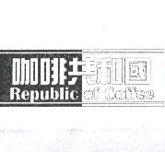 for coffee, charcoal-roasted coffee, coffee beans, coffee packs, etc.: "共和國" ("republic") refers to a country whose leader is not a monarch, but the use of "咖啡共和國" ("coffee republic") does not denote any existing country; instead, such combination gives consumers the impression of a provider of various kinds of coffee and conveys a unique business impression. Thus, no disclaimer for "咖啡" ("coffee") was required.

4.2 Use of homophones that creates a novel and unique impression
When the use of homophones gives consumers a novel and unique impression, it is usually because the non-distinctive element is combined with other elements to form an indivisible unit, so no disclaimer in respect of the non-distinctive element is required.
Accepted examples:
- "狠冰" for carbonated beverages, sports drinks, non-alcohol beverages containing fruit juices, tartaric acid beverages, etc.: Though "狠冰" ("hen-bin") sounds the same as "很冰" ("very cool"), which is descriptive of relevant goods, the combination creates a meaning beyond being mere descriptive. Therefore, no disclaimer of "很冰" was required.
- "膜術師" for anti-scratch films, anti-scratch films for mobile phones, protective plastic films for mobile phone cases, etc.: Though "膜" ("film") is a generic term of the designated goods, "膜術師" ("mo-shu-shi"), which sounds the same as "魔術師" ("magician"), creates a meaning other than the original meaning of the generic name. Thus, no disclaimer of "膜" was required.
- 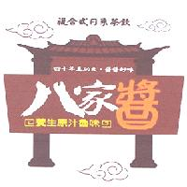for meat paste, stewed wings, salted meat, mutton hot pots, etc.: No disclaimer was required since "複合式日系茶飲" ("combined Japanese-style tea beverage"), "四十年真工夫" ("catering expert for forty years"), and "養生原汁魯味" ("original flavor that is good for your health") are obviously descriptive of the goods. Though "醬" of "八家醬" ("ba-jia-jiang") is descriptive of the condiments or seasonings for the designated goods, "八家醬," which sounds the same as "八家將" (a kind of special performer/performance at temple ceremonies"), creates a meaning other than the description of the designated goods. Thus, no disclaimer of "醬" was required. As for "醬醬好味" ("every sauce is tasty"), it is descriptive of the quality of goods but is not commonly used by the industry and the public, so a disclaimer was made.
- 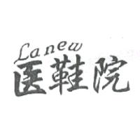for repair of shoes and boots: Though "醫鞋院" ("yi-xie-yuan") sounds similar to "醫學院" ("medical school"), such use creates a novel and interesting impression. Thus, no disclaimer of "鞋" was required.

4.3 Acquisition of distinctiveness through use
When a trademark as a whole is not distinctive but if relevant consumers, as a result of use of the trademark on the market, are able to identify the source of goods or services through the trademark, the registration of the trademark may be granted (Paragraph 2, Article 29 of the Trademark Act or Paragraph 4, Article 23 of the Trademark Act 2003). When a trademark includes a non-distinctive element, if relevant consumers, as a result of the use of the trademark on the market, are able to identify the source of goods or services through the non-distinctive element, such element has acquired distinctiveness. Under such circumstances, the entire trademark or the non-distinctive element thereof has acquired distinctiveness through extensive use and can trigger an indivisible impression in the minds of consumers. In turn, no disclaimer would be required in connection with the trademark or that non-distinctive element.
Accepted examples:
- 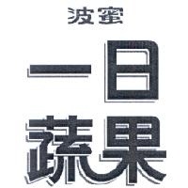 for fruit and vegetable juices: "一日蔬果" (daily consumption of vegetable and fruit) has acquired distinctiveness through use. Though "蔬果" is descriptive of the ingredients of the designated goods, the phrase "一日蔬果," through use, creates a unique impression as an indivisible unit. Therefore, no disclaimer of "蔬果" was required.
- 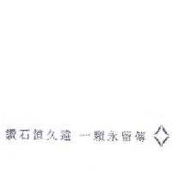 for precious stones and semi-precious stones, clocks, watches and chronometers, etc.: "鑽石恆久遠 一顆永流傳" ("A diamond lasts forever") has acquired distinctiveness through use. Even though "鑽石" ("diamond") is a generic term or is descriptive of the material of the designated goods, the phrase "鑽石恆久遠 一顆永流傳" has become an indivisible unit. Therefore, no disclaimer of "鑽石" was required.
• 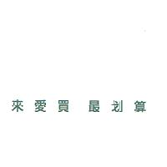 for department stores, supermarkets, shopping malls, mail order, etc.: A trademark as a whole has acquired distinctiveness through use (Article 29-2 of the Trademark Act). Although "最划算" ("best bargain") implies that the applicant's goods are better value for money than those of others, the trademark as a whole constitutes an indivisible unit. Therefore, no disclaimer of "最划算" was required.

5. Situation in which disclaimers are not applicable
No disclaimer is applicable to the situation in which a trademark is not distinctive because it merely consists of a description of the designated goods or services, or of the generic mark or generic term for the designated goods or services or of other non-distinctive signs (Paragraph 1, Article 29 of the Trademark Act), so the trademark application should be refused (Paragraph 1, Article 31 of the Trademark Act). A trademark may not be registered if it is likely to mislead the public with respect to the nature, quality, or place of origin of the designated goods or services (Subparagraph 8, Paragraph 1, Article 30 of the Trademark Act); such trademark application may not be granted even if a disclaimer is made. Additionally, since mere informative elements are not part of the business impression of a trademark that identifies its source, they cannot form a part of a trademark and cannot become eligible for application if a disclaimer is made.

5.1 Trademarks devoid of any distinctiveness in their entirety
When a trademark is not distinctive as a whole, it means that the trademark in its entirety cannot serve as a sign identifying the source of the goods or services. Even if a disclaimer of exclusive right to use the entire trademark or certain elements of the trademark is made, the trademark as a whole still cannot serve as a basis to identify the source. Under such circumstances, a disclaimer does not apply.
Refused examples:
- 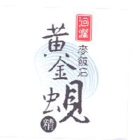 for nutritional supplements, nutritional supplements containing protein, nutritional preparations, clam essences, etc.: As "洄瀾" ("hui-lan") is the former name of Hualien and the applicant is located in Hualien, "洄瀾" is descriptive of the place of production of the goods. "麥飯石" ("maifan stone"), whose scientific name is "斑狀安山石" ("porphyries andesite"), has the function of water purification, and "黃金蜆精" refers to golden calm essence. Therefore, "麥飯石黃金蜆精" refers to golden calm essence made of calms that are raised in water filtered by maifan stones. As a consequence, "洄瀾" and "麥飯石黃金蜆精" are both descriptive of the designated goods. Additionally, the background design is a picture of the actual calm. The combination of the aforesaid Chinese terms and design give consumers the impression that they are descriptive of the designated goods, and cannot serve as a sign identifying the source. The entire trademark is not distinctive. Although the applicant disclaimed exclusive right to use the Chinese term "麥飯石黃金蜆精," the trademark was still refused.
• 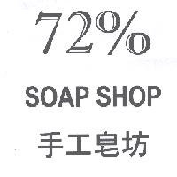 for perfumed soaps, perfumed soaps for baby, bath soaps, hand wash soaps, etc.: As 72% indicates the content of grease in soaps, the use of "SOAP SHOP," which is self-explanatory, and "手工皂坊" ("handmade soap shop") on the designated goods means that the trademark owner is the provider of the designated goods. Because "72%," "SOAP SHOP" and "手工皂坊" are all non-distinctive, the entire trademark is not distinctive and cannot be registered even though a disclaimer was made in respect of the descriptive words and characters.

5.2 Elements which are likely to mislead the public in respect of the nature, quality or place or origin of goods or services
When a trademark contains any element that is likely to mislead the public in respect of the nature, quality or place or origin of the goods or services, even if the applicant makes a disclaimer, consumers may still misidentify the source or may mistake the mark for another. Thus, the trademark is not registrable even if a disclaimer is made.
Refused examples:
- 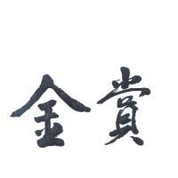 for rice, wheat, oats, sago, embryoed rice, etc.: As "金賞" ("gold award") means gold medal, the use of the term on the designated goods is likely to cause consumers to believe that those goods have been awarded in a competition or that the quality of the goods has won recognition in a competition. Therefore, the trademark application was refused.
-  for Chinese medicines, western medicines, mixed vitamins, preparations for clinical tests, etc.: As the use of "SWISS GUARANTEE SYSTEM" on the designated goods is likely to cause consumers to mistakenly believe that those goods are tested by a specific Swiss quality guarantee system, the trademark application was refused.

If deletion of any element of a trademark, which is likely to mislead the public in respect of the nature, quality or place or origin of the goods or services, will not cause substantial changes to the trademark, the applicant may be requested to delete such element before the trademark can be registered. For instance, an applicant must prove that the products that it markets are certified by a certification organization approved by the Council of Agriculture (COA) of the Executive Yuan (imported agricultural products and processed agricultural products with an international organic certification still have to be examined by the COA) in order to use the term "有機" ("organic") in connection with organic agricultural products/processed agricultural products and retail services thereof before such use. Trademarks that include the term "奈米" ("nano") can only be used in connection with nano-processed products, such as cosmetics or fabrics, or provision of nano-processing services. When an applicant cannot prove that its products have already acquired organic certification(s) from a certification organization, or when the designated goods or services are not restricted to nano-processed ones, registration of the trademark may be granted after the term "有機" or "奈米" is deleted, provided that such deletion does not substantially change the trademark (Article 23 of the Trademark Act). If the deletion will result in substantial changes to the trademark, the trademark application should be refused.
Refused examples:
- 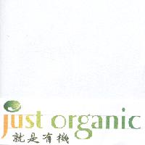 for retail of agricultural products, foods and beverages, etc.: As "就是有機" and "just organic" of the trademark give consumers the impression that the applicant provides organic products, but the applicant cannot prove that the products that it sells are certified by a certification organization approved by the COA, the trademark is likely to mislead the public in respect of the nature and quality of the goods offered by the services. Moreover, "就是有機," along with its English translation "just organics," is a slogan emphasizing the organic nature. As deletion of "有機" and "organic" from the trademark will result in a different impression, the deletion of those words will cause substantial changes to the trademark. Therefore, the application was refused.
- 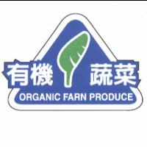 for organic fresh fruits and vegetables, organic fresh mushrooms, etc.: Because the applicant's products are not certified by a certification organization approved by the COA, "有機蔬菜" or "ORGANIC FARN PRODUCE" of the trademark is likely to cause relevant consumers to misidentify and to form a mistaken belief about the nature or quality of the goods. Since these terms are merely descriptive and do not form an indivisible unit when assessed with other elements of the trademark, their deletion will not substantially change the trademark. Nevertheless, as the applicant did not agree to the deletion, the application was refused.
- 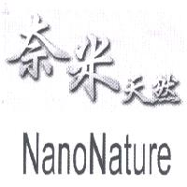 for pigments, dyes for the textile industry, paints, cement paints, etc.: As the designated goods are not confined to be nano-treated ones, and the trademark will be left with "天然" and "Nature" after the deletion of "奈米" and "Nano," which are descriptive of the goods, the entire trademark is not distinctive and the application was refused.

5.3 Purely informative elements
According to general business practice, other than trademarks and labels relating to goods, packaging, containers or other relevant articles used to convey the provided services, there are also elements that may indicate telephone number, fax number and address of manufacturer, agent or distributor, order information, ingredients, weight (net weight), date of manufacture, nutritional facts and other informative elements. Such information should be provided in accordance with the law or for marketing purposes. As any additional statement about the goods will not give consumers the impression that it is part of the trademark, it is not deemed as content of the trademark. Additionally, since mere informative elements will make the trademark more complicated and increase the difficulties in administrative filing, registration of the trademark cannot be granted unless the statement is deleted.

Moreover, ® and TM symbols are not deemed part of a trademark; instead, they are informative elements. The symbol "®," which means registered and is normally placed on the upper right corner of a registered trademark, can be used only after the concerned trademark is registered, while TM, which means trademark and indicates that the one who put it on desires to use the specific sign as a trademark, is normally also placed on the upper right corner of a registered or unregistered trademark. As ® and TM symbols are respectively used to indicate registered trademarks and registered trademarks/unregistered trademarks, neither is part of a trademark. Therefore, a trademark with such symbol may not be registered unless the symbol is deleted.
Accepted examples:
- 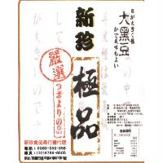 for black beans, kimchi, soy milk, meat and meat products: As information (telephone number, fax number and address) of the agent on the bottom left corner of the trademark and information (product name, ingredients, weight, period of preservation, expiry date, method of preservation and nutritional facts, etc.) on the bottom right corner are deemed merely informative elements, they were deleted.
- 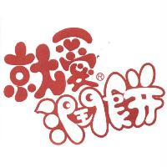 for Chinese burritos, burrito wraps, coffee-based beverages, black tea-based beverages, etc.: As "潤餅" is a generic term of part of the designated goods, no disclaimer was required; the symbol ® signifies a registered trademark and is deemed an informative element, so the trademark can be registered only after such symbol is deleted. The registration of the trademark was accepted after the applicant submitted the trademark specimen by deletion of the symbol ®, i.e. 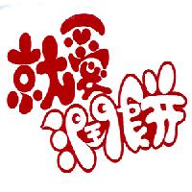.

6. Forms of disclaimer
In the past, a disclaimer was made by stating that "the disclaimed element" of the trademark is not for exclusive right to use. As noted, the registration of a trademark is to grant the right with respect to the entire trademark that is deemed distinctive, rather than to a specific element of the trademark. Also, the statement of "not for exclusive right to use" cannot fully express that the element of the trademark disclaimed for exclusive right to use is not granted trademark rights. To facilitate both trademark owners' and third parties' understanding of the content of a disclaimer, the Guidelines amends the form of disclaimer: "No claim is made to the exclusive right to use the word "the disclaimed word"/"the disclaimed design" apart from the trademark as shown." As to a disclaimer involving several disclaimed elements, obsolete or Simplified Chinese and foreign words, and complicated words/designs in the background, the following rules should be followed:

6.1 Disclaimer involving several elements
Where there are several elements that should be disclaimed, each element should be separated by a comma to clearly specify its content. For instance, if there are three elements to be disclaimed, a disclaimer should state: No claim is made to the exclusive right to use "disclaimed element 1," "disclaimed element 2," and "disclaimed element 3" apart from the trademark as shown.
Accepted examples:
- 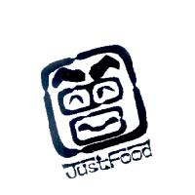 for kimchi, pickles, salty ginger and preserved cucumbers: Even though the surname "曾" ("zeng") is stylized, the character is still recognizable. Therefore, "曾" together with "JUST FOOD" was disclaimed: No claim is made to the exclusive right to use the words "曾" and "JUST FOOD" apart from the trademark as shown.
• 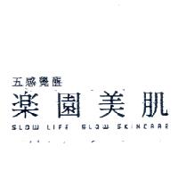 for cosmetics, cleansers for human use, perfumeries, tea bags for bathing, etc.: "五感覺醒" ("five senses awaken") and "SLOW LIFE SLOW SKINCARE" should be disclaimed for exclusive right to use: No claim is made to the exclusive right to use "五感覺醒" and "SLOW LIFE SLOW SKINCARE" apart from the trademark as shown.

6.2 Disclaimer in respect of specific classes or some of goods/services only
Whether any specific element of a trademark is distinctive must be determined in view of the designated goods or services. The descriptive or non-distinctive element of a trademark may become distinctive for certain classes or some of goods/services through the applicant's use. Therefore, if an element of a trademark is not distinctive only for certain classes or some of goods/services only, whereby there may be doubts relating to the scope of trademark rights, a disclaimer may be made in respect of those classes or some of goods/services: "No claim is made to the exclusive right to use the word "disclaimed words"/"disclaimed designs" in respect of specific classes/goods/services apart from the trademark as shown."
Accepted example:
- "度小月東坡" ("du-xiao-yuh-dongpo") for "jelly, herbal jelly, ai-yu jelly, tea jelly, jerky, meat crisp, dried meat floss, meat paste, minced pork sauce, etc." in Class 29: "蘇軾" ("Su Shi"), also known as "Resident of Dongpo," is not only a famous literary man from the North Sung Dynasty, but also rumored to be good at cooking. Su once said that a house without bamboo makes one vulgar and a diet without meat makes one lean ("無竹令人俗, 無肉令人瘦"). He created a dish called "東坡肉" ("Dongpo meat"), a famous Hangzhou cuisine. The use of the term "東坡" for meat products is descriptive, so a disclaimer was made: No claim is made to the exclusive right to use "東坡" in respect of the goods "jerky, meat crisp, dried meat floss, meat paste and minced pork sauce" apart from the trademark as shown.

6.3 Disclaimer in respect of a trademark that is mainly not distinctive
The commercial design of a product is the overall visual impression that it gives to consumers. When a trademark as a whole is able to produce a specific impression, the trademark may become registrable even if the majority of the trademark is non-distinctive words or designs and the distinctive element is only a small portion thereof. In order to clearly indicate the scope of trademark rights in a concise manner in such a case, a disclaimer should be made: No claim is made to the exclusive right to use the words (designs) other than "the distinctive element" apart from the trademark as shown.
Accepted examples:
- 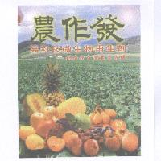 for trace element fertilizers for plants, liquid fertilizers, microorganism soil improvements, etc. As the trademark includes a non-distinctive background pattern and the descriptive phrase "高科技微生物再生劑創造新台灣農業奇蹟" ("high-tech microbiological regenerators create new agricultural miracle in Taiwan"), a disclaimer was made: No claim is made to the exclusive right to use the words (designs) other than "農作發" ("nong-zuo-fa") apart from the trademark as shown.
• 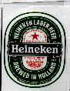 for beers. A disclaimer was made: No claim is made to the exclusive right to use the words other than "HEINEKEN" apart from the trademark as shown.
• 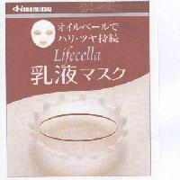 for cosmetics, lotions, skin care lotions, face masks, etc. A disclaimer was made: No claim is made to the exclusive right to use the words and designs other than "Hisamitsu" and "Lifecella" apart from the trademark as shown.
• 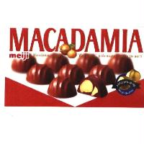 for chocolate products. A disclaimer was made: No claim is made to the exclusive right to use the words and designs other than "meiji" apart from the trademark as shown.
• 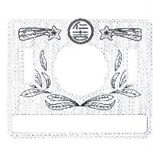 for vinegar, black vinegar, white vinegar, seasoning fruit vinegar, seasoning sauces, etc. A disclaimer was made: No claim is made to the exclusive right to use the designs other than "仁吉" ("ren ji") apart from the trademark as shown.

6.4 Disclaimer involving obsolete Chinese and Simplified Chinese
When a trademark contains any non-distinctive element which is obsolete Chinese or Simplified Chinese, thus likely to result in doubts over the scope of trademark rights, a disclaimer should be made: No claim is made to the exclusive right to use "the disclaimed Chinese characters" in obsolete Chinese/Simplified Chinese apart from the trademark as shown. When some of the Simplified Chinese characters to be disclaimed are identical to the corresponding Traditional Chinese ones, they are still considered Simplified Chinese and should be disclaimed in the same manner to avoid further complication.
Accepted examples:
- 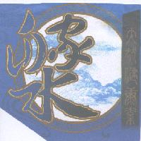 for Chinese medicines, western medicines, nutritional supplements, etc. A disclaimer was made: No claim is made to the exclusive right to use "天然健康素" ("natural healthy substance") and "藥" ("medicine") in obsolete Chinese apart from the trademark as shown.
- 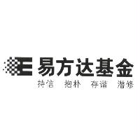 for financial analysis, capital investments, financial consultation and advisory services, saving banks, financial evaluation, etc. As "基金" ("fund") is commonly used to describe the services, no disclaimer was required; because "持信 抱樸 存諧 潛修" ("confidence, keeping innocent, harmony, religious practice") is a non-distinctive slogan, a disclaimer was made: No claim is made to the exclusive right to use "持信 抱樸 存諧 潛修" in Simplified Chinese apart from the trademark as shown.
• 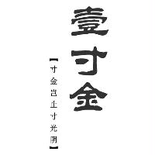 for Chinese herb, medicinal liquor, Chinese medicines, medicines for human use, etc.: A disclaimer was made to the slogan "寸金豈止寸光陰" ("an ounce of gold is more precious than every moment of time"): No claim is made to the exclusive right to use "寸金豈止寸光陰" in Simplified Chinese apart from the trademark as shown.

6.5 Disclaimer involving foreign words
When a trademark contains any non-distinctive foreign words, thus likely to result in doubts over the scope of trademark right, such foreign words should be disclaimed for exclusive right to use. However, considering the extent locals and competitors are likely to understand the foreign words, and the limitations of computer input methods, the disclaimer with respect to different languages should be made as follows:

English is familiar to most locals. Normally, English words without Chinese translation will not affect competitors' understanding. As TIPO's computer system is compatible with English input methods, a disclaimer in respect of English words can be made directly and no Chinese translation thereof is required. A disclaimer should be made by stating that no claim is made to the exclusive right to use "the disclaimed English word(s)" apart from the trademark as shown.

For foreign languages other than English that are not commonly understood by locals, if they are compatible with TIPO's computer system, such as Japanese, a disclaimer should state: No claim is made to the exclusive right to use "the disclaimed foreign words" which means "the Chinese translation " of "the foreign language" apart from the trademark as shown. If the foreign language is not compatible with TIPO's computer system, such as Korean and Arabic, a disclaimer should state: No claim is made to the exclusive right to use "the Chinese translation " of "the foreign language" apart from the trademark as shown.

Accepted examples:
- 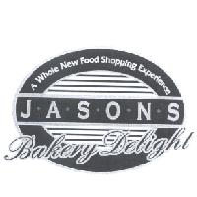for dry snack bars of cereal, bread, various biscuits, cakes, etc. As "BAKEERY DELIGHT" is self-explanatory and descriptive of the designated goods and is also commonly used to describe the designated goods by competitors and the public, no disclaimer thereto was made. However, the slogan "A WHOLE NEW FOOD SHOPPING EXPERIENCE," which means the experience in shopping for new foods," should be disclaimed for exclusive right to use: No claim is made to the exclusive right to use "A WHOLE NEW FOOD SHOPPING EXPERIENCE" apart from the trademark as shown.
- 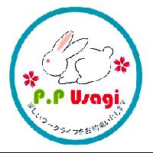for bedding, quilts, bed sheets, etc. As the slogan "樂﹣約束" means "want to reserve a happy working life," a disclaimer was made: No claim is made to the exclusive right to use "樂﹣約束" which means "want to reserve a happy working life" in Japanese apart from the trademark as shown.
-  for massage, aromatic therapy services, healthy hot spring bath services, etc. As the Spanish slogan "DONDE EL AGUA ES VIDA" means "where there is water, there is life," a disclaimer was made:
No claim is made to the exclusive right to use "DONDE EL AGUA ES VIDA" which means "where there is water, there is life" in Spanish apart from the trademark as shown.
•  for baby foods, baby foods (excluding emulsified flour for baby), emulsified flour for baby, etc. A disclaimer was made: No claim is made to the exclusive right to use the words "Oriental Formula for Babies" and "royal formula" in Korean apart from the trademark as shown.

7. Other matters

7.1 When no response is made by the time limit after receipt of a notice of disclaimer
Where a trademark contains a non-distinctive element, thus likely to give rise to doubts over the scope of trademark rights, a disclaimer should be made according to the law. Such trademark can be accepted for registration only after the applicant has disclaimed exclusive right to use that element. If after receipt of a pre-notice of disapproval, the applicant fails to state if he/she agrees to a disclaimer by the time limit, because the applicant may consider such element as having distinctiveness and desire to claim exclusive right to use, then TIPO will disapprove such trademark application. If dissatisfied with such outcome, the applicant can resort to administrative remedies for final decision on whether or not such element is distinctive.

7.2 When non-disclaimed words in a registered trademark become non-distinctive in a later-filed application
Whether elements in a trademark are non-distinctive should be determined at the time when the trademark is examined. If a later-filed trademark contains any word included in another registered trademark and no disclaimer of the word is made in connection with the existing trademark on account of non-distinctiveness, but such word is found to be descriptive, generic term or non-distinctive based on objective facts during examination of the later-filed application, or such word through combination with other words is no longer the main distinctive element of the later-filed trademark and is merely descriptive of the goods or services, then the later-filed trademark is not likely to confuse relevant consumers and may be granted registration. In such a case, the trademark owner of the earlier-filed trademark or any third party cannot raise objection on the grounds that the earlier-filed trademark has been registered or that no disclaimer is made for the earlier-filed trademark. However, since that non-disclaimed element can be found in the earlier-registered trademark and was not disclaimed, if the reason why the later-filed trademark is granted registration rather than being refused is based on the grounds that there is no clear likelihood of confusing relevant consumers, the owner of the earlier-filed trademark may still claim his/her right to exclude others' use of the non-distinctive word. Considering the fact that the owner of the later-filed trademark and competitors may not know such wording has no distinctiveness, in order to clearly state that the relevant word of the later-filed trademark is not distinctive, the trademark owner should only be allowed to acquire the registration thereof after such element is disclaimed for exclusive right to use.
For example, "好幫手" was registered for kitchen countertops, gas stoves, beverage dispensers, furnaces, etc. on 16 January 2001, while an application for registration of  was filed in connection with kitchen countertops, water heaters, beverage dispensers, furnaces, etc. on 27 June 2007. Although the latter contains "好幫手" ("good helper") and is designated for use on goods identical or similar to those designated for the earlier-registered "好幫手," as the use of "居家好幫手" ("good helper at home") on the designated goods signifies that those goods can improve convenience at home, the "好幫手" is descriptive of the effectiveness of the designated goods. Although the later-filed trademark might be granted registration because there was no likelihood of confusing relevant consumers, to explicitly identify "居家好幫手" as having no distinctiveness, the registration of the trademark was granted after a disclaimer of exclusive right to use "居家好幫手" was made.
"省電達人" was registered for powder savers, energy economizers, switches, transformers, etc. on 1 May 2006. "達人" ("tatsujin"), which means expert in Japanese, has been so extensively used by locals that, when an application for registration of 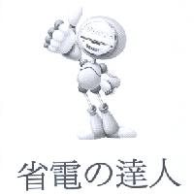 in connection with electric egg beaters, electric fruit peelers, washing machines, etc. was filed in 2008, the general public could understand that "省電達人" meant "expert in energy conservation," and thus the phrase was descriptive of the designated goods. Although the registration of the later-filed trademark might be granted because there was no likelihood of confusing relevant consumers, to explicitly identify "省電達人" as having no distinctiveness, the registration of the trademark was granted after a disclaimer of exclusive right to use such characters was made.

7.3 Acquisition of distinctiveness after a disclaimer is made
If the descriptive or other non-distinctive elements of an earlier-filed trademark application which has been registered with a disclaimer then acquire distinctiveness through use, and if the trademark owner applies to register such elements as a trademark or part of a trademark in a separate application, the trademark may be registered on account of having acquired distinctiveness (Paragraph 2, Article 29 of the Trademark Act), so no disclaimer in respect of the elements is required. Such trademark application is not bound by the disclaimer made in the earlier-filed trademark application.
For example, 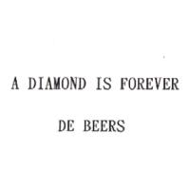 for diamonds, gemstones, clocks and watches inlaid diamonds, etc.: "A DIAMOND IS FOREVER" is descriptive of the goods and an advertising slogan. Such slogan was granted registration in 2001 after a disclaimer was made. After extensive use of the trademark on the market, "A DIAMOND IS FOREVER" has acquired distinctiveness. When filing another trademark application, the registration of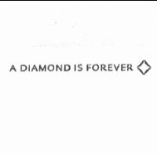for precious stones and semi-precious stones, clocks, watches and chronometers, etc. was accepted without requiring a disclaimer.

7.4 Distinctive elements may not be disclaimed for exclusive right to use
When a trademark contains a distinctive element that denotes and identifies the source, generally the applicant has no reason to disclaim such element. If the applicant disclaims exclusive right to use such distinctive element, he/she may be requested to provide an explanation therefor. If such disclaimer is made because of the applicant's misunderstanding, he/she would be informed that the disclaimer is not required and be allowed to withdraw the disclaimer.
In practice, some applicants have tried to register their trademarks by disclaiming the distinctive elements of those trademarks which are similar to registered or earlier-filed trademarks. However, since the inclusion of such elements in those trademarks will inevitably create a likelihood of confusing consumers, the registration of those trademarks cannot be obtained even if disclaiming the distinctive elements that are similar to earlier-filed trademarks.

7.5 No publication will be made for the element of a trademark that is disclaimed by the applicant but is unlikely to give rise to any doubts over the scope of trademark rights
The disclaimer system aims to explicitly define the scope of trademark rights. Therefore, when a trademark contains a non-distinctive element that is likely to give rise to doubts over the scope of trademark rights, a disclaimer is required. To the contrary, when the non-distinctive element is unlikely to give rise to any doubts over the scope of trademark rights, no disclaimer is required. The applicant's disclaimer of an element of a trademark may not be prohibited by law. However, to avoid interference with the judgment of whether it "could give rise to doubts as to the scope of the trademark rights," the disclaimed element will not be published on the Trademark Gazette.

7.6 Determination of likelihood of confusion should be based on observation of entire trademarks
Whether a trademark is likely to cause confusion is determined from the consumers' perspective. It is the entirety of a trademark, rather than the individual parts separately, that is presented to the relevant consumers. Therefore, determination of similarity between trademarks should be based on observation of the entire trademarks. When a trademark contains a non-distinctive element, regardless whether or not such element is disclaimed for exclusive right to use because it may likely give rise to doubts over the scope of trademark rights or whether or not such element is not disclaimed because no doubt is likely to occur, even though the disclaimed element of the trademark may not serve as the element that identifies the goods or services, it may still affect the determination of similarity between trademarks.
For instance, in a prior case in which 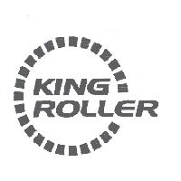 is designated for use on contact rollers, rollers (mechanical parts), etc., "ROLLER" means rollers and is a generic term of the designated goods, and therefore, the registration of the trademark was granted without a disclaimer, while in a later case, an application was filed to register 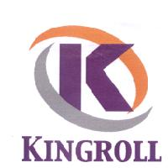 in connection with contact rollers, rollers, rollers (mechanical parts), etc. As "KING ROLLER" and "KINGROLL" are the important distinctive elements of the two trademarks and share the letters "KINGROLL," though there is a difference in "ER," the two trademarks only differ slightly in appearance and sound. Thus, they are deemed similar trademarks. Moreover, they are both designated for use on similar goods, so there is a likelihood of confusing consumers. Given this, the later case was refused even though "ROLLER" of the prior-filed trademark application is not distinctive.

